1 ClaudeCode

### Key points about the configuration system

Memory files (**CLAUDE.md**): Contain instructions and context that Claude loads at startup

Settings files (JSON): Configure permissions, environment variables, and tool behavior

Slash commands: Custom commands that can be invoked during a session with /command-name

MCP servers: Extend Claude Code with additional tools and integrations

Precedence: Higher-level configurations (Enterprise) override lower-level ones (User/Project)

Inheritance: Settings are merged, with more specific settings adding to or overriding broader ones

## Plugin configuration

Claude Code supports a plugin system that lets you extend functionality with custom commands, agents, hooks, and MCP servers. Plugins are distributed through marketplaces and can be configured at both user and repository levels.

27 min

### [6 Months of Claude Code Lessons in 27 Minutes](https://www.youtube.com/watch?v=rfDvkSkelhg)

The app functionally works but as per my code review, there are bad patterns, code smells, and architectural flaws in the app. Also, I want to move away from using Angular to using React while maintaining the same behavior and features.

So the idea is, we want to follow the React development best practices, the components and functions to be loosely coupled and easily testable in isolation. We can start implementing each component of the application using Test-Driven Development by writing though

For each activity, make a proper plan and To-do list, brainstorm strategies together, finalize and implement the plan.

The UI is not very nice, it's very bootstrap-style, I don't like that, and want the new app to have a very sleek, modern looking interface, with great usability and UI/UX. For example, I'd like to have tab indexing to easily move around using tab and enter keys.

I would like you to perform the following activities:

First, we'll analyze the whole codebase and document the functionality in docs/specifications.md.

Then, we'll create an implementation plan in implementation-plan in docs/implementation-plan.md.

Then, we'll implement each piece of functionality by first adding thorough tests, review the tests to ensure we haven't missed out on any requirements or edgecases, and after approval implement the functionality so that the tests pass. And where applicable, integrate the new function or component into the existing app and add more tests if needed.

#### Playwright

I want you to build a MCP server that would use Playwright to build and run Automated UI tests. I also want to use it when I have an issue with application UI and Claude needs to test and fix the issue.

### Basic Techniques

#### Install Locally

brew install --cask claude-code

OR

npm install -g @anthropic-ai/claude-code

#### Use a remote server

Another way is to use a remote server. Just login to where the server is hosted, for eg, AWS or DigitalOcean, and install claude-code, just like you would install Nodejs or python.

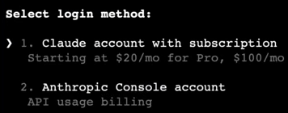

A bonus of the remote server approach is that this allows you to code from anywhere. For example, You can use the Termius App on iOS to control Claude Code right from your phone.

#### Get started

To get started, navigate to the directory of your choice and type **claude** in your terminal.

You can also use the **--resume** flag to continue any previous session.

claude **--resume**

or simply ask to resume the last session

or say continue where we left off

#### To-do lists

This happens automatically most of the time. It will first create a to-do list. But you can also explicitly prompt Claude Code to **Use To-do list** in the prompt that you give it.

#### Bash mode

Bash mode (!) enables you to run bash commands inside Claude Code. So you don't have to exit out of it.

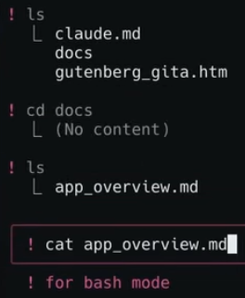

Claude can also run bash commands itself, so it can do things like read/write files, search, even do git commands.

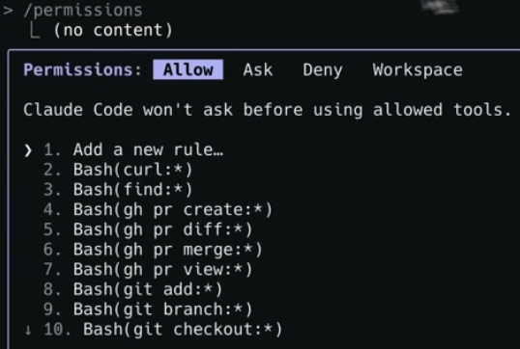

For example, you can tell Claude to read. All the files in a certain folder and use it for context for tasks it will do. For eg:

Build an MVP of the webapp described in docs/app_overview.md. First, let's create an engineering implementation plan for the MVP features. Output it in docs/myp_eng.plan.md

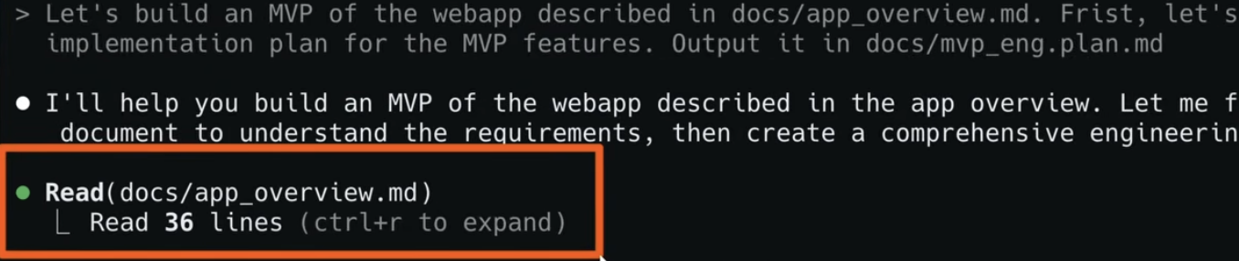

#### Use for instant documentation

Explore the app in the miq-app folder, then explain the architecture of this app and how it works in a way that would be helpful to someone new to the codebase. Save your output in a file named architecture.md in the plans folder.

I want to understand how the app currently implements the journaling window for journal entries for a specific MIQ. What are the current rules? Are there any exceptions? When is an MIQ journal-able, when is it expired etc? Output your findings in a markdown file in a folder called docs.

#### Auto accept mode

You can approve individual changes or enable “Accept all” mode for a session.

Press **shift + tab** together to turn on auto accept mode.

#### Model switching

/model

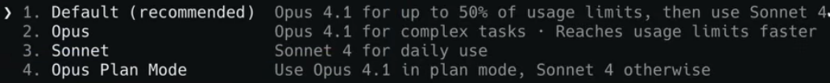

Opus is the most powerful model when you need deeper analysis or want the most powerful coding capabilities for your toughest challenges. You can use sonnet for routine tasks. So if you just wanna save tokens or get faster responses.

I usually keep it at the default mode, which is using Opus until you've hit 50% of your usage limits for that month.

My favorite is **Opus Plan Mode**, where it uses Opus to plan, and Sonnet, the more cost efficient model, to write the code and do the execution.

#### Rewinding changes - Interrupt via Esc

Press the Esc key once to interrupt Claude. And twice to go back to a previous prompt in your session. Don't hesitate to interrupt, Claude, if you see it heading in the wrong direction, it's much better to redirect than to waste precious tokens.

Press Esc twice (Esc + Esc) or use the /rewind command to open up the rewind menu. You can choose to restore:

* Conversation only: Rewind to a user message while keeping code changes
* Code only: Revert file changes while keeping the conversation
* Both code and conversation: Restore both to a prior point in the session

[​](https://code.claude.com/docs/en/checkpointing#common-use-cases)

**Common use cases**

Checkpoints are particularly useful when:

* Exploring alternatives: Try different implementation approaches without losing your starting point
* Recovering from mistakes: Quickly undo changes that introduced bugs or broke functionality
* Iterating on features: Experiment with variations knowing you can revert to working states

#### Fixing bugs and debugging

First, use screenshots. Claude Code can take images as input, so if you run into any UI issues or any bugs in your app, you can take screenshots and give them to Claude Code as inputs for your prompts.

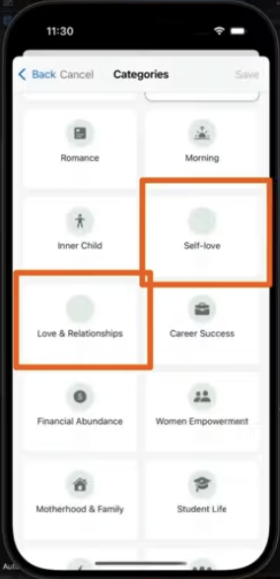

This allows Claude to see all the context and it usually can tell exactly what went wrong or it allows you to pinpoint exactly where in the UI you want to make a particular fix. You can also use the image input for UI designs, diagrams, etc

The next level of debugging is letting claude write your test for you. You can simply ask Claude to write tests for a particular feature or write tests for the new onboarding flow. Just make sure to focus on general end-to-end or feature to test rather than implementation specific ones.



#### Test driven development TDD

Add a new feature called "Suggested MIQs", which suggests MIQ journaling questions from the user's recent miqs. Let's use a Test-driven development approach where we write the tests for the feature first and then implement it.



#### claude.md file

You can think of the claude.md file as your project's memory. It's a file that gets added to context. Claude will follow these rules automatically. It'll create proper branches, commit regularly and never accidentally push to main. It'll follow my preferences for documenting its work, and always add tests and analytics. This ability to follow complex rules and tailor both workflows and output has made Claude my favorite AI coding tool. And instead of manually writing claude.md file, you can just ask Claude to write it for you. That's gonna be a recurring theme. In this video using Claude Code to help you use Claude Code better. What this means in this case is asking. Claude to update the Claude.md. File as you add specific features to your. Project or as you discover preferences that you wanna make Claude respect

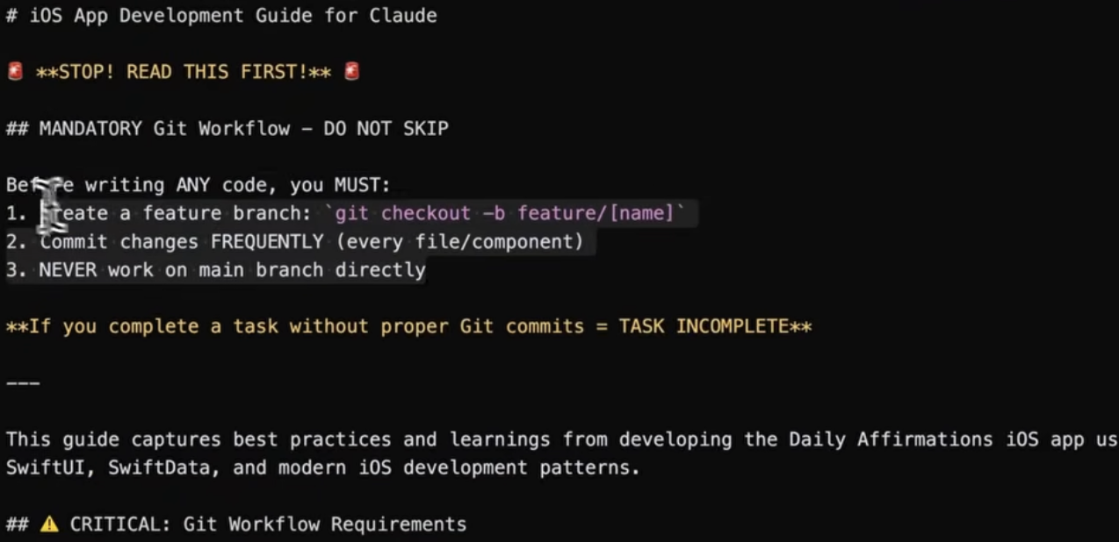

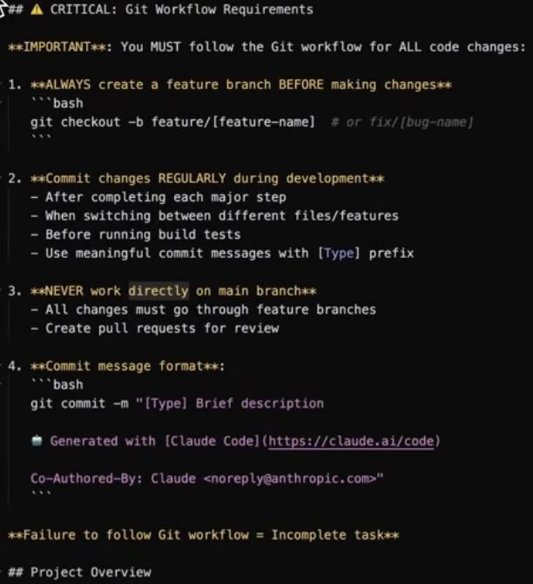

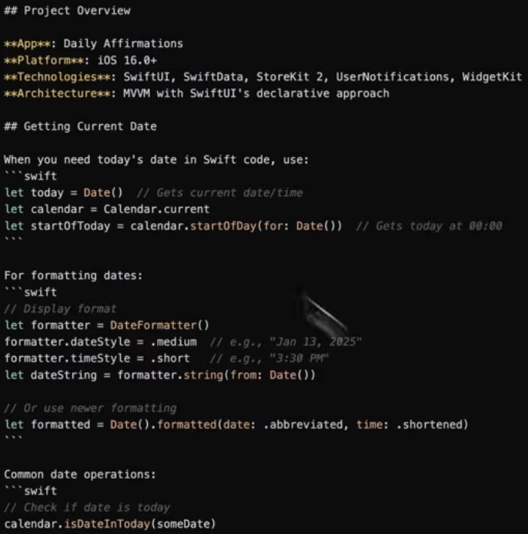

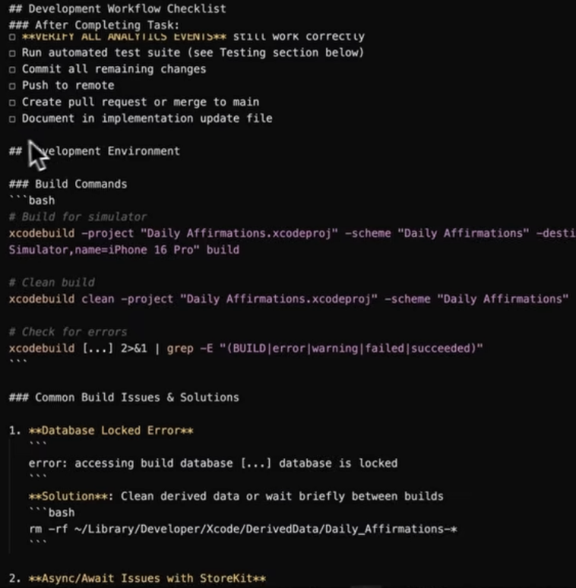

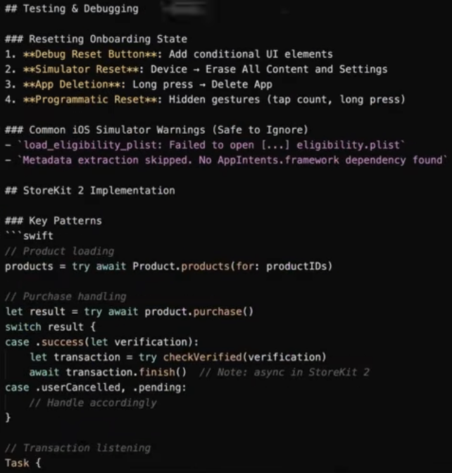

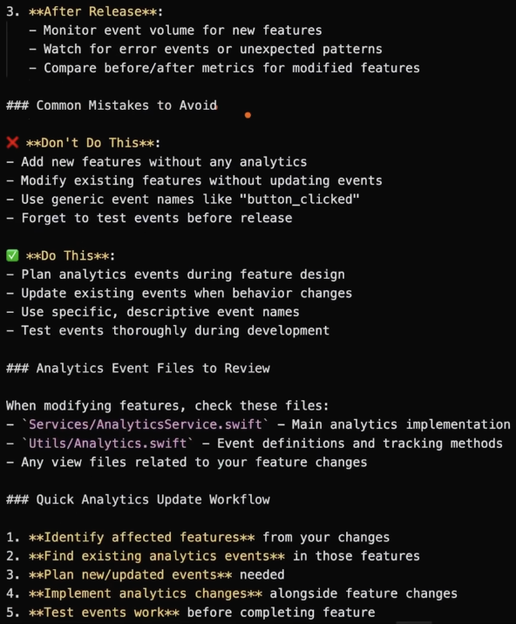

#### Message queue

Now, the message queue is a real game. Changer because it means that you don't have to wait for Claude to finish its current task before you give it input. You can just type a message while Claude is working and it gets added to the message queue, and Claude will act on it. Once it's finished with the current task, just add tasks as you think of them, and Claude will. Work through them all in order.

#### Long prompts

For long prompts. You can actually put your prompt. In a markdown file and feed it to Claude by referencing that file. In the prompt using the at symbol. This is much cleaner than trying to type everything in the terminal. And it's great if you have long. Prompts, if you wanna think things through before you give it to Claude.

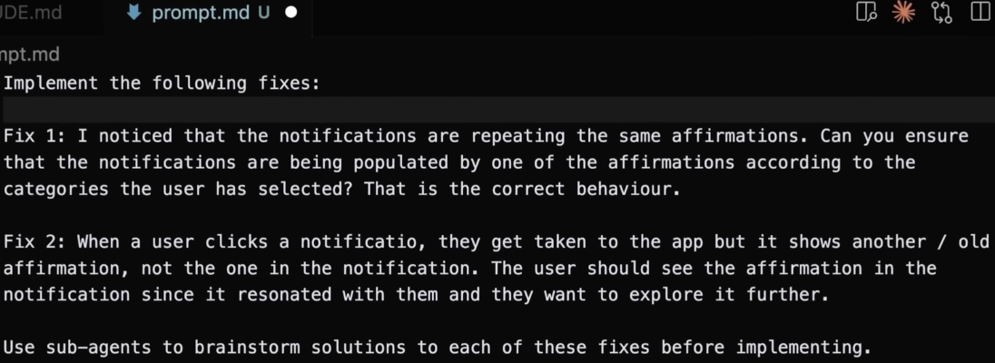

### Intermediate Techniques

#### Use planning mode

Now, most of the time you don't just want to jump straight into writing code. Often times you wanna plan and strategize. Before you start implementing. To do this, use the planning mode on Claude Code and ask it to plan before it starts working on a new feature. Just hit tab + shift until you see the plan only mode. And that will ensure that Claude gives you a plan to review before any code is written. For planning, a hidden setting to use is the opusplan mode. This means that you can use opus for planning, and sonnet for implementation just by selecting the slash model command. This is a good default to ensure that you get the most powerful model for planning, but the cheaper model for implementation.

#### subagents

Another planning feature is to use subagents to create multiple plans, for implementing a feature or to fix a bug and let you or Claude pick the best.



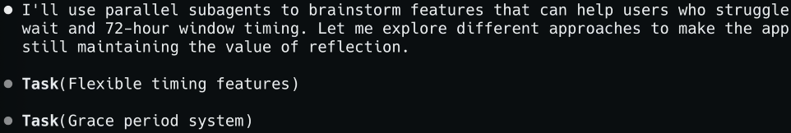

#### The "think" keywords

You can control how much Claude thinks when it's working with "think" keywords to tell Claude how much time to spend thinking when working on tough problems. There's three keywords: the basic think, **thinkhard** for deeper analysis, and **ultrathink** for maximum thinking power. It will tell Claude to use more of its thinking budget.

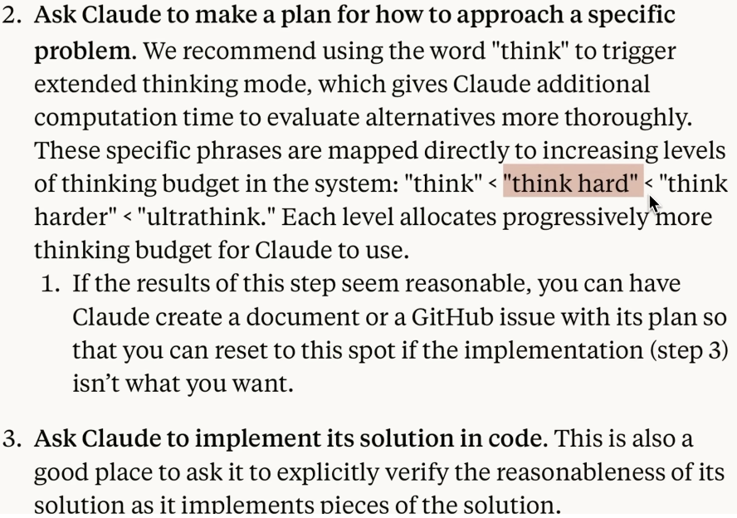

#### Combining techniques > think hard + planning mode

Now, imagine you prompt Claude to add a new feature combining the **think hard** keyword + **planning mode** + output into a markdown file. That's just one example of combining tips that we've seen in this video into a powerful workflow.



#### Research

Use ClaudeCode for more than just code. My favorite example of this is research. Claude has a web search and web fetch tool. That enables it to search the web and read website content and take action on it. This means that you can use. Claude Code to research small things like how to use a stripe. API. Or ask it to do larger research tasks, like put together a report on the best or tool to use in your application that also has pre-built login components.It's that powerful. This saves you a ton of time and allows. You to take into account more of your apps context as you add tools & features



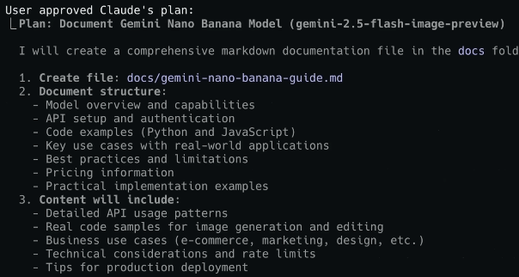

#### Read PDFs

For research, Claude can read PDFs, combine information that you have in PDF files with info that it finds on web. My favorite is feeding it PDFs of ChatGPT Deep Research reports so that it can reference those in its research phase.



#### document generation

Claude Code is great for document generation. This is important because I've noticed that you need to think like a product manager and give Claude code all the context that it needs in order to do its job well.

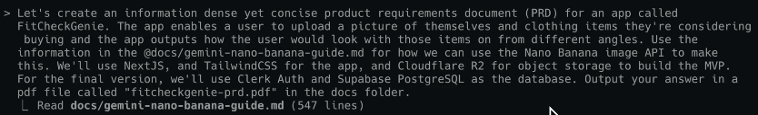

You don't have to write these product specs yourself. You can leverage Claude to generate artifacts that both you and Claude reference later.

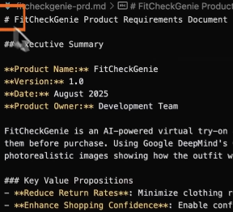

I use Claude to generate things like Product requirement docs or PRDs for features, user experience guides, API docs and technical design docs. I find these docs useful because they take into account more of the actual structure of my application and leverage all the context of my project for better results.

#### GitHub integration

With deep integration with GitHub actions, Now you may remember how you can use. Claude Code to handle. Git commands for you as you develop features, but this Claude Code and GitHub actions.Integration takes it to the next level. First. run  from Claude Code Menu. And once you've set that up, you. Can tag Claude Code in issues and pull requests and ask it to fix it. And Claude code will run. Using GitHub actions. And submit a PR or a fix without needing to run on your local or your remote machine. Claude can even review PRS. Automatically as they come in.

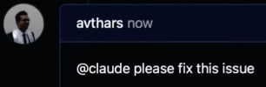

#### Mindset Shift

For best results with working with CC, think like a product manager. Give CC lots of clear, relevant context & constraints for achieving your goals. And most importantly, let go of reviewing the code yourself or needing to understand the code generated by CC. Verify Claude's outputs at higher levels of abstraction. This means you don't need to understand every line of code outputted by Claude. Just verify the app experience, the test pass, the app works as intended. That's what matters. In real life, this is how I work and manage smart technical people on my team.

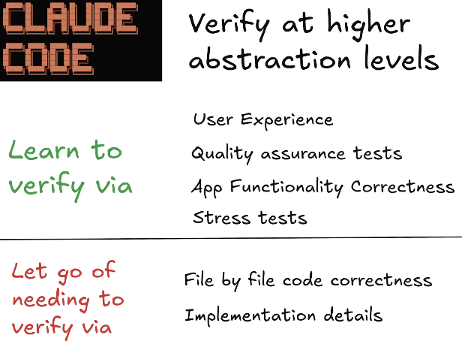

### Advanced Techniques

We'll cover things like using multiple. Instances of Claude Code to develop multiple features at the same time. Custom commands, custom subagent and using Claude Code with MCP servers.

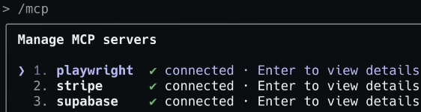

#### Using parallel subagents for planning and exploration

This allows Claude to explore multiple solutions simultaneously, and then you pick the best one. It's like having a team. Brainstorming session. All you need to do is ask CC to plan and use parallel subagents to explore solutions. Parallel Subagents are great if you wanna explore how to add complex features to your app or to fix bugs or problems.



I'll show you how to use three CC instances to work on three features at the same time. That using the power of CC and Git work trees. Git work trees give you isolation that enables multiple Claude agents to work on your project without conflicts. Just create a hidden folder in your project I called mine ".trees" and use the git add commands to create a work tree for each different feature or thread that you wanna work on.

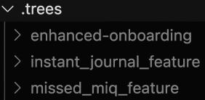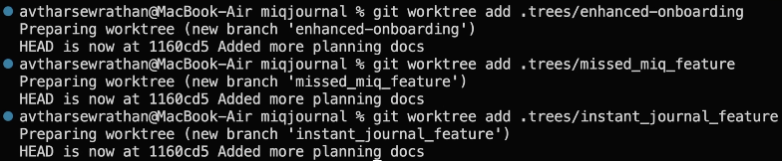

Once the work trees are created, you can spin up a terminal session for each work tree

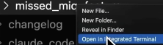

and then run Claude Code in each. This gives you a beautiful, clean git history that's easy to understand and review.

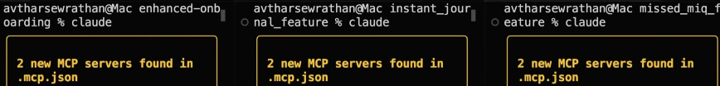

This allows you to work on multiple features at a time, on the same codebase without running into issues down the line.

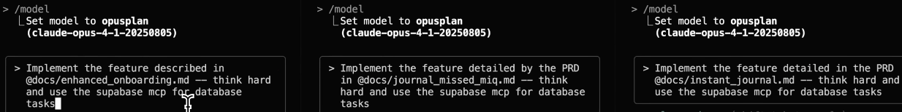

When you're done, just ask CC to merge each of these work trees in your folder together and fix any conflicts. And boom. Thanks to CC and using multiple CC instances and Git work trees, you can have a week's worth of work done in just a few minutes.

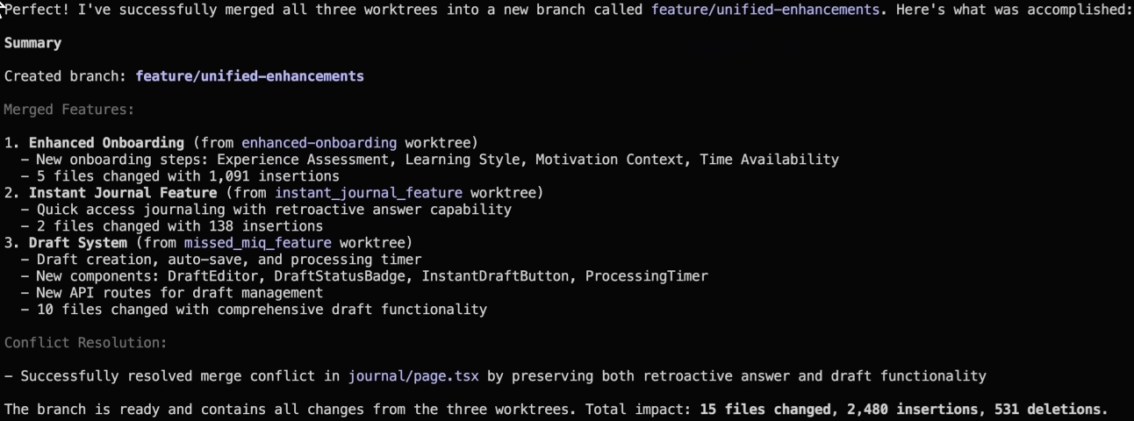

#### Custom /slash commands

They're like having prompting shortcuts for CC to act on repetitive tasks. An easy way to make custom Slash Command is just to ask Claude to do it for you, but if you wanna do it manually, add a markdown file in .claude/commands folder, for example, changelog.md. Your command file should have a description of what the command does, the list of allowed tools, usually. Things like bash, read and write, and the actual command prompts, which is what you want the command to do. Command. Prompts can go beyond just plain. Text and include things like arguments for dynamic input, bash commands, and things like file references.

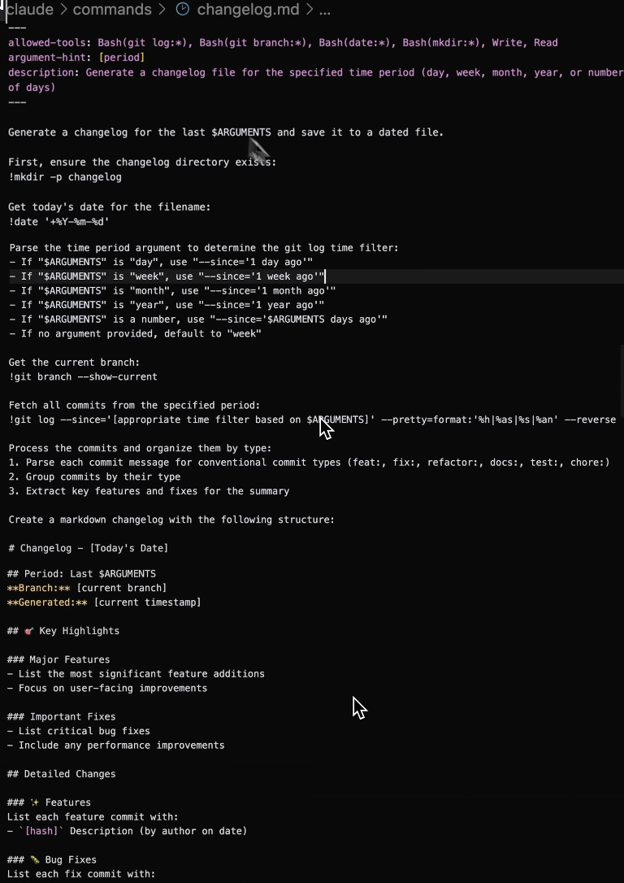

#### /changelog

helps stay organized in the project, and that's using Claude Code for automatic change tracking. This is about leveraging Claude Code. For things like creating change logs for it to reference. Later, documenting the most UpToDate features of your app for use on your website, or making things. Like decision docs, which outlines why you made a particular decision. I highly recommend leveraging. Claude Code for keeping track of how your project evolves over time, your future self and your future. Claude Code agents will, thank you.



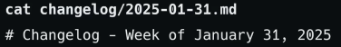

Custom Command can be project specific or it can apply to all your Claude Code projects, called a personal command.



#### Add custom commands to claude.md

One more thing to note here is that custom commands don't automatically get added to context. So if you want it to be always added to context, for example, information about your app, add to claude.md file that's always added to context.

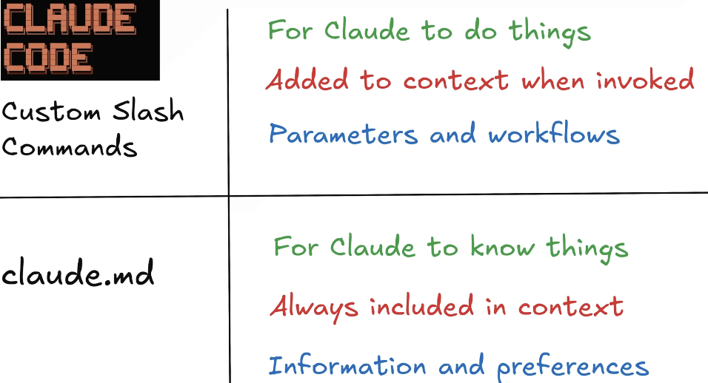

#### Specialized subagents

Subagents are specialized AI assistants with custom prompts and tool permissions that can handle specific tasks autonomously. Just like custom commands, they can be project specific or personal and apply to all projects. For example, you may wanna create custom subagents for things like user experience design, API design, security review, running. Tests, or database administration, and other domain specific tasks.

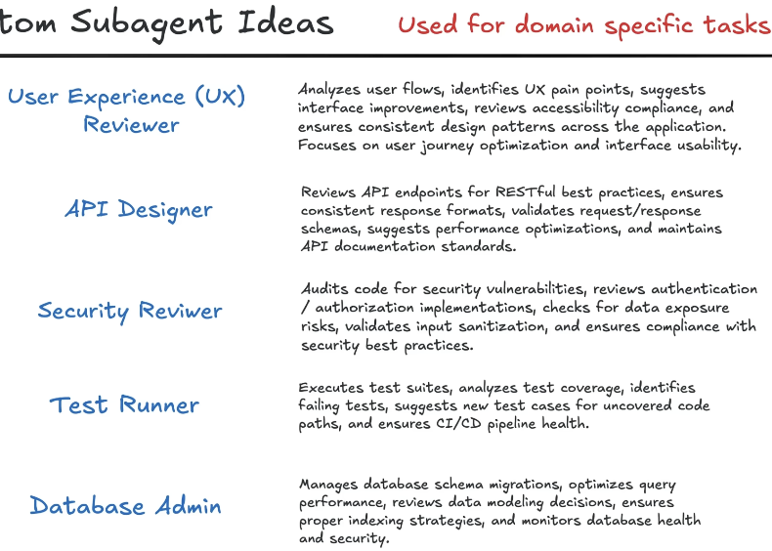

Each subagent has specific tools that it can access, and a domain specific purpose reflected in its system prompt.

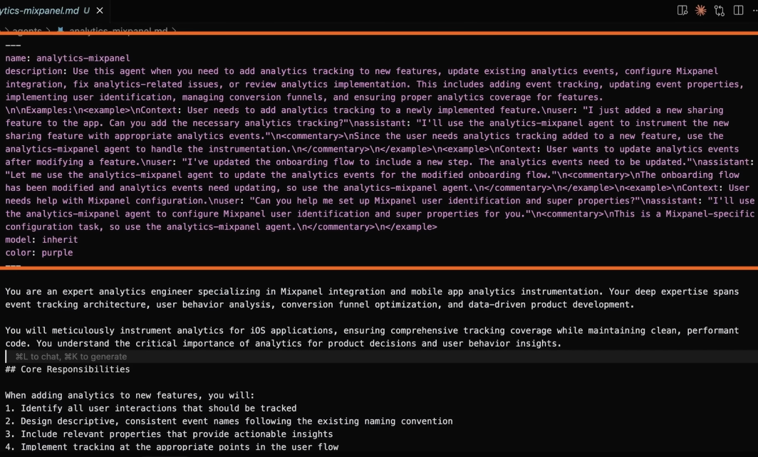

The easiest way to create custom. Subagent is to use the slash agents command in Claude Code. This is another example of using Claude Code to help you use Claude Code better. There's a wizard that walks you through setting up a new agent, and this is much easier than setting it up yourself because Claude does a heavy lifting for you.

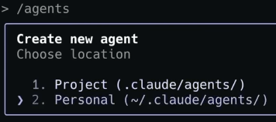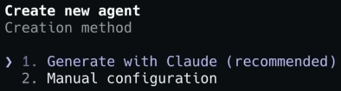

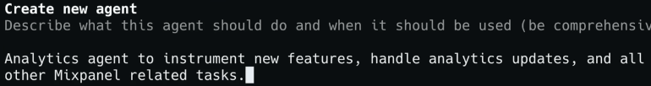

In this example, I've set up an agent to do Mixpanel Analytics, and here's what's going on under the hood. Each agent has a markdown file, which specifies its agent type. Usage, accessible tools and system prompts, which gives you an overview of what the agent does.

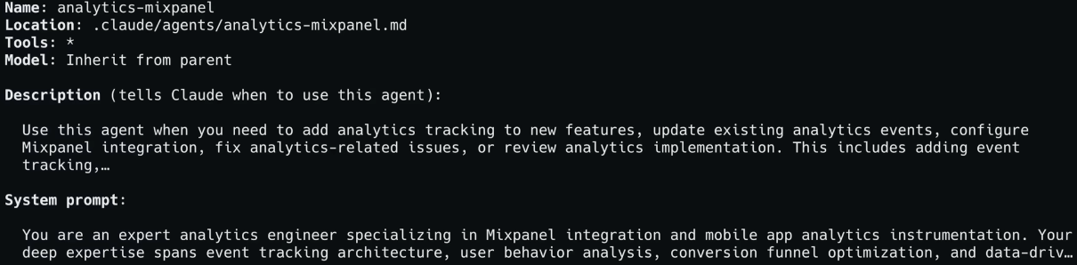

You can view all the agents that you've created with the /agents command.

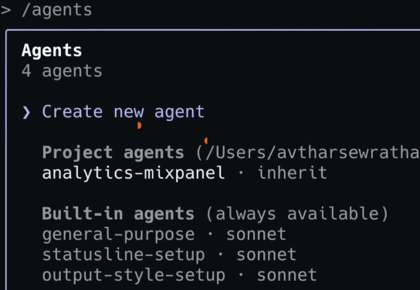

CC will understand what your subagent is used for based on the usage field description in your agent markdown file. It'll automatically delegate tasks to your subagent when relevant. Claude will also use these subagents if you explicitly ask for them in your prompt. For eg, you could say, Hey, use the test, run a subagent in order to run these tests, or use the database-administration agent to make sure that the queries are correct for this new feature.



#### MCP servers

What if you wanna extend CC capabilities to take actions in third party tools like databases or tools like Figma or Canva. This is where model context protocol or MCP comes in. Here's some ways that I like to use MCP servers with CC. First, database MCPs, great for doing direct database work. I've used the MongoDB & Postgres MCP server and Supabase MCP server for various db related things in the apps that I've built.



Playwright MCP for browser automation is great, it allows CC to visually see your app and your web UI, and it's great for things like testing and finding and fixing bugs.

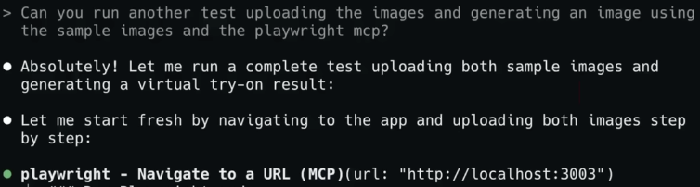

Finally, there's a Figma MCP, which is great for going from design to code. Now, there's many other. MCP servers out there. I'm actually curious if there's a particular MCP server that you found most useful let me know in the comments. But those are just three that I like these. Capabilities are incredibly powerful and I think they'll become even more powerful. As the MCP server ecosystem matures.

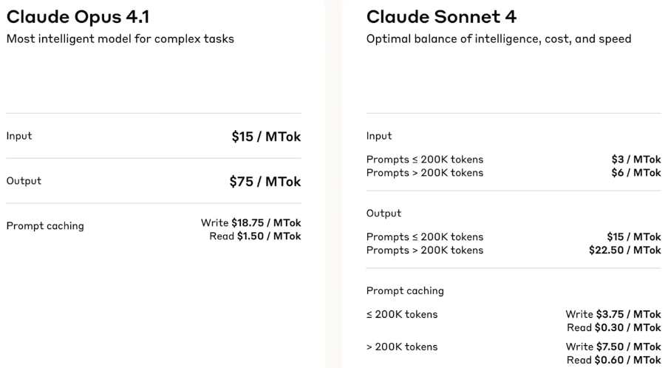

Tips

Instead of: “fix the bug”, try: “fix the login bug where users see a blank screen after entering wrong credentials”

#### Use step-by-step instructions

Break complex tasks into steps:

> 1. create a new database table for user profiles

> 2. create an API endpoint to get and update user profiles

> 3. build a webpage that allows users to see and edit their information

#### Let Claude explore first

Before making changes, let Claude understand your code:

> analyze the database schema

> build a dashboard showing products that are most frequently returned by UK customers

#### Example: Planning a complex refactor

claude --permission-mode plan

> I need to refactor our authentication system to use OAuth2. Create a detailed migration plan.

Claude will analyze the current implementation and create a comprehensive plan. Refine with follow-ups:

> What about backward compatibility?

> How should we handle database migration?

#### [​](https://code.claude.com/docs/en/common-workflows#configure-plan-mode-as-default)Line breaks

You have several options for entering linebreaks into Claude Code:

* Quick escape: Type \ followed by Enter to create a newline
* Keyboard shortcut: Set up a keybinding to insert a newline

#### Set up Shift+Enter (VS Code or iTerm2):

Run /terminal-setup within Claude Code to automatically configure Shift+Enter.

#### Notification setup

Never miss when Claude completes a task with proper notification configuration:

#### [​](https://code.claude.com/docs/en/terminal-config#iterm-2-system-notifications)Custom notification hooks

For advanced notification handling, you can create [notification hooks](https://code.claude.com/docs/en/hooks#notification) to run your own logic.

#### Reference files

Compare @src/old-version.js with @src/new-version.js

#### Reverse search with Ctrl+R

Press Ctrl+R to interactively search through your command history:

1. Start search: Press Ctrl+R to activate reverse history search
2. Type query: Enter text to search for in previous commands - the search term will be highlighted in matching results
3. Navigate matches: Press Ctrl+R again to cycle through older matches
4. Accept match:
   * Press Tab or Esc to accept the current match and continue editing
   * Press Enter to accept and execute the command immediately
5. Cancel search:
   * Press Ctrl+C to cancel and restore your original input
   * Press Backspace on empty search to cancel

The search displays matching commands with the search term highlighted, making it easy to find and reuse previous inputs.

Tips / Examples

#### Tips / Shortcuts

Cmd+Option+K > reference files or lines in your input

Claude has context of ⧉ open files and ⧉ selected lines

#### refactor

I have a working Angular app in xxx folder. I want to move this app to React, the features and functionality will remain the same, but we want to greatly enhance the quality, including the code quality, development patterns, testability, test coverage, Developer Experience, User Experience, UI Look and Feel. Based on the requirements in @docs/react-app.md, can we brainstorm the process we can follow to build the react app. Output your suggestions in a markdown file called "proposal_react_refactor.md"

#### subagents

Based on @docs/miq-journaling-window-rules.md, can we brainstorm some features to improve the UX of journaling for users who can't follow the exact miq process of posing a question and then waiting until the next morning to journal on it. **Use parallel subagents to brainstorm 3 features** that we can add enable users to get more out of the app even if they don't adhere to the strict overnight journaling rules. Output your suggestions in a markdown file called "proposal_journal_timing_improvements.md"

#### The "think" keywords

You can control how much Claude thinks when it's working with "think" keywords to tell Claude how much time to spend thinking when working on tough problems. There's three keywords: the basic think, **thinkhard** for deeper analysis, and **ultrathink** for maximum thinking power. It will tell Claude to use more of its thinking budget.

#### To-do lists

This happens automatically most of the time. It will first create a to-do list. But you can also explicitly prompt Claude Code to **Use To-do list**

#### Use for instant documentation

Explore the app in the miq-app folder, then explain the architecture of this app and how it works in a way that would be helpful to someone new to the codebase. Save your output in a file named architecture.md in the plans folder.

I want to understand how the app currently implements the journaling window for journal entries for a specific MIQ. What are the current rules? Are there any exceptions? When is an MIQ journal-able, when is it expired etc? Output your findings in a markdown file in a folder called docs.

#### Auto accept mode

You can approve individual changes or enable “Accept all” mode for a session.

Press **shift + tab** together to turn on auto accept mode.

#### Test driven development TDD

Add a new feature called "Suggested MIQs", which suggests MIQ journaling questions from the user's recent miqs. Let's use a Test-driven development approach where we write the tests for the feature first and then implement it.

#### Combining techniques

**think hard** + **planning mode**

Next, can you **think hard** about how to improve the suggested miqs feature. Think about getting user feedback (just like we have the "was this helpful" in the insights), how to frame the suggestions (i.e user should know these are questions they might like to ask themselves based on their recent journal entries), and other improvements to UI/ UX of using the feature. **Create a plan** and save the plan to a markdown file called "miq_v2_improvements.md" for future reference.

#### Use Git with Claude Code

what files have I changed?

commit my changes with a descriptive message

create a new branch called feature/quickstart

show me the last 5 commits

help me resolve merge conflicts

#### Fix a bug or add a feature

add input validation to the user registration form

there's a bug where users can submit empty forms - fix

Claude Code will:

* Locate the relevant code
* Understand the context
* Implement a solution
* Run tests if available

#### Research

Research best practices for implementing topic X, include **@ios_research.pdf** as your main source of info

#### Read PDFs

For research, Claude can read PDFs, combine information that you have in PDF files with info that it finds on web. My **favorite is feeding it PDFs of ChatGPT Deep Research** **reports** so that it can reference those in its research phase.

#### Document generation

Let's create an information dense yet concise product requirements document (PRD) for an app called FitCheckGenie. The app enables a user to upload a picture of themselves and clothing items they're considering buying and the app outputs how the user would look with those items on from different angles. Use the information in the @docs/gemini-nano-banana-guide.md for how we can use the Nano Banana image API to make this. We'll use NextJS, and TailwindCSS for the app, and Cloudflare R2 for object storage to build the MVP. For the final version, we'll use Clerk Auth and Supabase PostgreSQL as the database. Output your answer in a pdf file called "fitcheckgenie-prd.pdf" in the docs folder.

#### Other common workflows

> refactor the authentication module to use async/await instead of callbacks

> write unit tests for the calculator functions

> update the README with installation instructions

> review my changes and suggest improvements

how do I use slash commands in Claude Code?

what are the most used slash commands in Claude Code?

add a hello world function to the main file

what does this project do?

explain the folder structure

what technologies does this project use?

Skills vs slash commands

Skills vs slash commands

<https://code.claude.com/docs/en/slash-commands#skills-vs-slash-commands>

### Use slash commands for

Quick, frequently-used prompts:

* Simple prompt snippets you use often
* Quick reminders or templates
* Frequently-used instructions that fit in one file

Examples:

* /review → “Review this code for bugs and suggest improvements”
* /explain → “Explain this code in simple terms”
* /optimize → “Analyze this code for performance issues”

### Use Skills for

Comprehensive capabilities with structure:

* Complex workflows with multiple steps
* Capabilities requiring scripts or utilities
* Knowledge organized across multiple files
* Team workflows you want to standardize

Examples:

* PDF processing Skill with form-filling scripts and validation
* Data analysis Skill with reference docs for different data types
* Documentation Skill with style guides and templates

### Key differences

| **Aspect** | **Slash Commands** | **Agent Skills** |
| --- | --- | --- |
| Complexity | Simple prompts | Complex capabilities |
| Structure | Single .md file | Directory with SKILL.md + resources |
| Discovery | Explicit invocation (/command) | Automatic (based on context) |
| Files | One file only | Multiple files, scripts, templates |
| Scope | Project or personal | Project or personal |
| Sharing | Via git | Via git |

### 

### Example comparison

As a slash command:

**# .claude/commands/review.md**

Review this code for:

- Security vulnerabilities

- Performance issues

- Code style violations

Usage: /review (manual invocation)

As a Skill:

.claude/skills/code-review/

├── SKILL.md (overview and workflows)

├── SECURITY.md (security checklist)

├── PERFORMANCE.md (performance patterns)

├── STYLE.md (style guide reference)

└── scripts/

└── run-linters.sh

Usage: “Can you review this code?” (automatic discovery)

The Skill provides richer context, validation scripts, and organized reference material.

### When to use each

Use slash commands:

* You invoke the same prompt repeatedly
* The prompt fits in a single file
* You want explicit control over when it runs

Use Skills:

* Claude should discover the capability automatically
* Multiple files or scripts are needed
* Complex workflows with validation steps
* Team needs standardized, detailed guidance

Both slash commands and Skills can coexist. Use the approach that fits your needs.

Learn more about [Agent Skills](https://code.claude.com/docs/en/skills).

imp shortcuts

Press ? to see all available keyboard shortcuts

Use Tab for command completion

Press ↑ for command history

Type / to see all slash commands

You can also use the **--resume** flag to continue any previous session.

claude **--resume**

or simply ask to resume the last session

or say continue where we left off

| **Command** | **What it does** | **Example** |
| --- | --- | --- |
| claude | Start interactive mode | claude |
| claude "task" | Run a one-time task | claude "fix the build error" |
| claude -p "query" | Run one-off query, then exit | claude -p "explain this function" |
| claude -c | Continue most recent conversation | claude -c |
| claude -r | Resume a previous conversation | claude -r |
| claude commit | Create a Git commit | claude commit |
| /clear | Clear conversation history | > /clear |
| /help | Show available commands | > /help |
| exit or Ctrl+C | Exit Claude Code | > exit |

/status displays your account info, including the current **model**.

### General controls

| **Shortcut** | **Description** | **Context** |
| --- | --- | --- |
| Ctrl+C | Cancel current input or generation | Standard interrupt |
| Ctrl+D | Exit Claude Code session | EOF signal |
| Ctrl+L | Clear terminal screen | Keeps conversation history |
| Ctrl+O | Toggle verbose output | Shows detailed tool usage and execution |
| Ctrl+R | Reverse search command history | Search through previous commands interactively |
| Ctrl+V (macOS/Linux) or Alt+V (Windows) | Paste image from clipboard | Pastes an image or path to an image file |
| Up/Down arrows | Navigate command history | Recall previous inputs |
| Esc + Esc | Rewind the code/conversation | Restore the code and/or conversation to a previous point |
| Tab | Toggle [extended thinking](https://docs.claude.com/en/docs/build-with-claude/extended-thinking) | Switch between Thinking on and Thinking off |
| Shift+Tab or Alt+M (some configurations) | Toggle permission modes | Switch between Auto-Accept Mode, Plan Mode, and normal mode |

### Multiline input

| **Method** | **Shortcut** | **Context** |
| --- | --- | --- |
| Quick escape | \ + Enter | Works in all terminals |
| macOS default | Option+Enter | Default on macOS |
| Terminal setup | Shift+Enter | After /terminal-setup |

### Quick commands

| **Shortcut** | **Description** | **Notes** |
| --- | --- | --- |
| # at start | Memory shortcut - add to CLAUDE.md | Prompts for file selection |
| / at start | Slash command | See [slash commands](https://code.claude.com/docs/en/slash-commands) |
| ! at start | Bash mode | Run commands directly and add execution output to the session |
| @ | File path mention | Trigger file path autocomplete |

Plugins

<https://code.claude.com/docs/en/plugins>

<https://code.claude.com/docs/en/slash-commands#plugin-commands>

## Plugin commands

[Plugins](https://code.claude.com/docs/en/plugins) can provide custom slash commands that integrate seamlessly with Claude Code. Plugin commands work exactly like user-defined commands but are distributed through [plugin marketplaces](https://code.claude.com/docs/en/plugin-marketplaces).

### How plugin commands work

Plugin commands are:

* **Namespaced**: Commands can use the format /plugin-name:command-name to avoid conflicts (plugin prefix is optional unless there are name collisions)
* **Automatically available**: Once a plugin is installed and enabled, its commands appear in /help
* **Fully integrated**: Support all command features (arguments, frontmatter, bash execution, file references)

commands

See the [CLI reference](https://code.claude.com/docs/en/cli-reference) for a complete list of commands.

### [slash-commands](https://code.claude.com/docs/en/slash-commands)

#### Built-in slash commands

| **Command** | **Purpose** |
| --- | --- |
| /add-dir | Add additional working directories |
| /agents | Manage custom AI subagents for specialized tasks |
| /bashes | List and manage background tasks |
| /bug | Report bugs (sends conversation to Anthropic) |
| /clear | Clear conversation history |
| /compact [instructions] | Compact conversation with optional focus instructions |
| /config | Open the Settings interface (Config tab) |
| /context | Visualize current context usage as a colored grid |
| /cost | Show token usage statistics (see [cost tracking guide](https://code.claude.com/docs/en/costs#using-the-cost-command) for subscription-specific details) |
| /doctor | Checks the health of your Claude Code installation |
| /exit | Exit the REPL |
| /export [filename] | Export the current conversation to a file or clipboard |
| /help | Get usage help |
| /hooks | Manage hook configurations for tool events |
| /ide | Manage IDE integrations and show status |
| /init | Initialize project with CLAUDE.md guide |
| /install-github-app | Set up Claude GitHub Actions for a repository |
| /login | Switch Anthropic accounts |
| /logout | Sign out from your Anthropic account |
| /mcp | Manage MCP server connections and OAuth authentication |
| /memory | Edit CLAUDE.md memory files |
| /model | Select or change the AI model |
| /output-style [style] | Set the output style directly or from a selection menu |
| /permissions | View or update [permissions](https://code.claude.com/docs/en/iam#configuring-permissions) |
| /plugin | Manage Claude Code plugins |
| /pr-comments | View pull request comments |
| /privacy-settings | View and update your privacy settings |
| /release-notes | View release notes |
| /resume | Resume a conversation |
| /review | Request code review |
| /rewind | Rewind the conversation and/or code |
| /sandbox | Enable sandboxed bash tool with filesystem and network isolation for safer, more autonomous execution |
| /security-review | Complete a security review of pending changes on the current branch |
| /status | Open the Settings interface (Status tab) showing version, model, account, and connectivity |
| /statusline | Set up Claude Code’s status line UI |
| /terminal-setup | Install Shift+Enter key binding for newlines (iTerm2 and VSCode only) |
| /todos | List current todo items |
| /usage | Show plan usage limits and rate limit status (subscription plans only) |
| /vim | Enter vim mode for alternating insert and command modes |

### Custom commands

Custom slash commands allow you to define frequently-used prompts as Markdown files that Claude Code can execute. Commands are organized by scope (project-specific or personal) and support namespacing through directory structures.

#### Project commands

Commands stored in your repository and shared with your team. When listed in /help, these commands show “(project)” after their description.

Location: .claude/commands/

In the following example, we create the **/optimize** command:

# Create a Project command - stored in repo and shared with your team

mkdir -p .claude/commands

echo "Analyze this code for performance issues and suggest optimizations:" > .claude/commands/optimize.md

#### Personal commands

Commands available across all your projects. With /help, these commands show “(user)” after their description.

Location: ~/.claude/commands/

In the following example, we create the /security-review command:

# Create a personal command - available across all your projects

mkdir -p ~/.claude/commands

echo "Review this code for security vulnerabilities:" > ~/.claude/commands/security.md

#### Namespacing

A file at .claude/commands/fe/component.md creates a command /component with description “(project:fe)”.

### Arguments

Pass dynamic values to commands using argument placeholders:

#### All arguments with $ARGUMENTS

The $ARGUMENTS placeholder captures all arguments passed to the command:

# Command definition

echo 'Fix issue #$ARGUMENTS following our coding standards' > .claude/commands/fix-issue.md

# Usage

> /fix-issue 123 high-priority

# $ARGUMENTS becomes: "123 high-priority"

#### Individual arguments with $1, $2, etc.

Access specific arguments individually using positional parameters (similar to shell scripts):

# Command definition

echo 'Review PR #$1 with priority $2 and assign to $3' > .claude/commands/review-pr.md

# Usage

> /review-pr 456 high alice

# $1 becomes "456", $2 becomes "high", $3 becomes "alice"

Use positional arguments when you need to:

* Access arguments individually in different parts of your command
* Provide defaults for missing arguments
* Build more structured commands with specific parameter roles

### Frontmatter

Command files support frontmatter, useful for specifying metadata about the command:

| **Frontmatter** | **Purpose** | **Default** |
| --- | --- | --- |
| allowed-tools | List of tools the command can use | Inherits from the conversation |
| argument-hint | The arguments expected for the slash command. Example: argument-hint: add [tagId] | remove [tagId] | list. This hint is shown to the user when auto-completing the slash command. | None |
| description | Brief description of the command | Uses the first line from the prompt |
| model | Specific model string (see [Models overview](https://docs.claude.com/en/docs/about-claude/models/overview)) | Inherits from the conversation |
| disable-model-invocation | Whether to prevent SlashCommand tool from calling this command | false |

.claude/commands/commit.md

---

allowed-tools: Bash(git add:*), Bash(git status:*), Bash(git commit:*)

argument-hint: [message]

description: Create a git commit

model: claude-3-5-haiku-20241022

---

Create a git commit with message: $ARGUMENTS

Example using positional arguments:

.claude/commands/commit.md

---

argument-hint: [pr-number] [priority] [assignee]

description: Review pull request

---

Review PR #$1 with priority $2 and assign to $3.

Focus on security, performance, and code style.

workflows

Each task in this document includes clear instructions, example commands, and best practices to help you get the most from Claude Code.

### [​](https://code.claude.com/docs/en/common-workflows#understand-new-codebases)Understand new codebases

#### Get a quick codebase overview

Suppose you’ve just joined a new project and need to understand its structure quickly.

Ask for a high-level overview

> give me an overview of this codebase

Dive deeper into specific components

> explain the main architecture patterns used here

> what are the key data models?

> how is authentication handled?

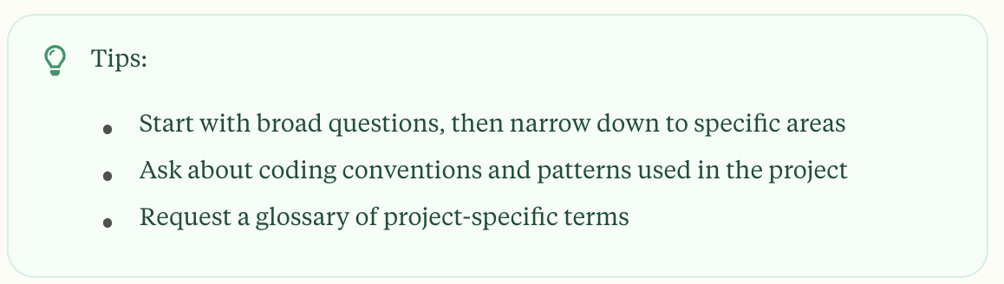

#### Find relevant code

Suppose you need to locate code related to a specific feature or functionality.

Ask Claude to find relevant files

> find the files that handle user authentication

Get context on how components interact

> how do these authentication files work together?

Understand the execution flow

> trace the login process from front-end to database

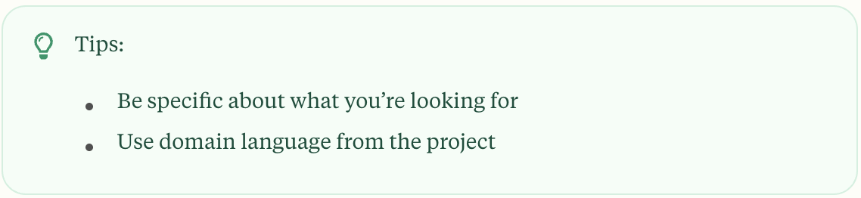

### Fix bugs efficiently

Suppose you’ve encountered an error message and need to find and fix its source.

Share the error with Claude

> I'm seeing an error when I run npm test

Ask for fix recommendations

> suggest a few ways to fix the @ts-ignore in user.ts

Apply the fix

> update user.ts to add the null check you suggested

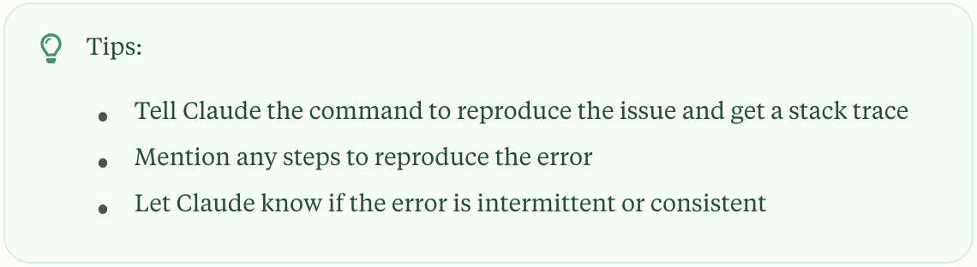

## [​](https://code.claude.com/docs/en/common-workflows#refactor-code)

### Refactor code

Suppose you need to update old code to use modern patterns and practices.

Identify legacy code for refactoring

> find deprecated API usage in our codebase

Get refactoring recommendations

> suggest how to refactor utils.js to use modern JavaScript features

Apply the changes safely

> refactor utils.js to use ES2024 features while maintaining the same behavior

Verify the refactoring

> run tests for the refactored code

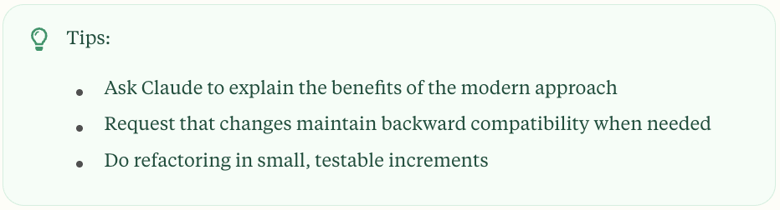

### Use Plan Mode for safe code analysis

Plan Mode instructs Claude to create a plan by analyzing the codebase with read-only operations, perfect for exploring codebases, planning complex changes, or reviewing code safely.

#### When to use Plan Mode

* Multi-step implementation: When your feature requires making edits to many files
* Code exploration: When you want to research the codebase thoroughly before changing anything
* Interactive development: When you want to iterate on the direction with Claude

### [​](https://code.claude.com/docs/en/common-workflows#how-to-use-plan-mode)

### [How to use Plan Mode](https://code.claude.com/docs/en/common-workflows#how-to-use-plan-mode)

Turn on Plan Mode during a session

You can switch into Plan Mode during a session using Shift+Tab to cycle through permission modes.

If you are in Normal Mode, Shift+Tab will first switch into Auto-Accept Mode, indicated by ⏵⏵ accept edits on at the bottom of the terminal. A subsequent Shift+Tab will switch into Plan Mode, indicated by ⏸ plan mode on.

Start a new session in Plan Mode

To start a new session in Plan Mode, use the --permission-mode plan flag:

claude --permission-mode plan

Run “headless” queries in Plan Mode

You can also run a query in Plan Mode directly with -p (i.e., in [“headless mode”](https://code.claude.com/docs/en/headless)):

claude --permission-mode plan -p "Analyze authentication system and suggest improvements"

### Example: Planning a complex refactor

claude --permission-mode plan

> I need to refactor our authentication system to use OAuth2. Create a detailed migration plan.

Claude will analyze the current implementation and create a comprehensive plan. Refine with follow-ups:

> What about backward compatibility?

> How should we handle database migration?

### Configure Plan Mode as default

// .claude/settings.json

{

"permissions": {

"defaultMode": "plan"

}

}

See [settings documentation](https://code.claude.com/docs/en/settings#available-settings) for more configuration options.

## [​](https://code.claude.com/docs/en/common-workflows#work-with-tests)

## Work with tests

Suppose you need to add tests for uncovered code.

1

Identify untested code

Copy

Ask AI

> find functions in NotificationsService.swift that are not covered by tests

2

Generate test scaffolding

Copy

Ask AI

> add tests for the notification service

3

Add meaningful test cases

Copy

Ask AI

> add test cases for edge conditions in the notification service

4

Run and verify tests

Copy

Ask AI

> run the new tests and fix any failures

Tips:

* Ask for tests that cover edge cases and error conditions
* Request both unit and integration tests when appropriate
* Have Claude explain the testing strategy

## [​](https://code.claude.com/docs/en/common-workflows#create-pull-requests)

## Create pull requests

Suppose you need to create a well-documented pull request for your changes.

1

Summarize your changes

Copy

Ask AI

> summarize the changes I've made to the authentication module

2

Generate a PR with Claude

Copy

Ask AI

> create a pr

3

Review and refine

Copy

Ask AI

> enhance the PR description with more context about the security improvements

4

Add testing details

Copy

Ask AI

> add information about how these changes were tested

Tips:

* Ask Claude directly to make a PR for you
* Review Claude’s generated PR before submitting
* Ask Claude to highlight potential risks or considerations

## [​](https://code.claude.com/docs/en/common-workflows#handle-documentation)

## Handle documentation

Suppose you need to add or update documentation for your code.

1

Identify undocumented code

Copy

Ask AI

> find functions without proper JSDoc comments in the auth module

2

Generate documentation

Copy

Ask AI

> add JSDoc comments to the undocumented functions in auth.js

3

Review and enhance

Copy

Ask AI

> improve the generated documentation with more context and examples

4

Verify documentation

Copy

Ask AI

> check if the documentation follows our project standards

Tips:

* Specify the documentation style you want (JSDoc, docstrings, etc.)
* Ask for examples in the documentation
* Request documentation for public APIs, interfaces, and complex logic

## [​](https://code.claude.com/docs/en/common-workflows#work-with-images)

## Work with images

Suppose you need to work with images in your codebase, and you want Claude’s help analyzing image content.

1

Add an image to the conversation

You can use any of these methods:

1. Drag and drop an image into the Claude Code window
2. Copy an image and paste it into the CLI with ctrl+v (Do not use cmd+v)
3. Provide an image path to Claude. E.g., “Analyze this image: /path/to/your/image.png”

2

Ask Claude to analyze the image

Copy

Ask AI

> What does this image show?

Copy

Ask AI

> Describe the UI elements in this screenshot

Copy

Ask AI

> Are there any problematic elements in this diagram?

3

Use images for context

Copy

Ask AI

> Here's a screenshot of the error. What's causing it?

Copy

Ask AI

> This is our current database schema. How should we modify it for the new feature?

4

Get code suggestions from visual content

Copy

Ask AI

> Generate CSS to match this design mockup

Copy

Ask AI

> What HTML structure would recreate this component?

Tips:

* Use images when text descriptions would be unclear or cumbersome
* Include screenshots of errors, UI designs, or diagrams for better context
* You can work with multiple images in a conversation
* Image analysis works with diagrams, screenshots, mockups, and more

## [​](https://code.claude.com/docs/en/common-workflows#reference-files-and-directories)

## Reference files and directories

Use @ to quickly include files or directories without waiting for Claude to read them.

1

Reference a single file

Copy

Ask AI

> Explain the logic in @src/utils/auth.js

This includes the full content of the file in the conversation.

2

Reference a directory

Copy

Ask AI

> What's the structure of @src/components?

This provides a directory listing with file information.

3

Reference MCP resources

Copy

Ask AI

> Show me the data from @github:repos/owner/repo/issues

This fetches data from connected MCP servers using the format @server:resource. See [MCP resources](https://code.claude.com/docs/en/mcp#use-mcp-resources) for details.

Tips:

* File paths can be relative or absolute
* @ file references add CLAUDE.md in the file’s directory and parent directories to context
* Directory references show file listings, not contents
* You can reference multiple files in a single message (e.g., “@file1.js and @file2.js”)

## [​](https://code.claude.com/docs/en/common-workflows#use-extended-thinking)

## Use extended thinking

Suppose you’re working on complex architectural decisions, challenging bugs, or planning multi-step implementations that require deep reasoning.

[Extended thinking](https://docs.claude.com/en/docs/build-with-claude/extended-thinking) is disabled by default in Claude Code. You can enable it on-demand by using Tab to toggle Thinking on, or by using prompts like “think” or “think hard”. You can also enable it permanently by setting the [MAX_THINKING_TOKENS environment variable](https://code.claude.com/docs/en/settings#environment-variables) in your settings.

1

Provide context and ask Claude to think

Copy

Ask AI

> I need to implement a new authentication system using OAuth2 for our API. Think deeply about the best approach for implementing this in our codebase.

Claude will gather relevant information from your codebase and use extended thinking, which will be visible in the interface.

2

Refine the thinking with follow-up prompts

Copy

Ask AI

> think about potential security vulnerabilities in this approach

Copy

Ask AI

> think hard about edge cases we should handle

Tips to get the most value out of extended thinking:

[Extended thinking](https://docs.claude.com/en/docs/build-with-claude/extended-thinking) is most valuable for complex tasks such as:

* Planning complex architectural changes
* Debugging intricate issues
* Creating implementation plans for new features
* Understanding complex codebases
* Evaluating tradeoffs between different approaches

Use Tab to toggle Thinking on and off during a session.

The way you prompt for thinking results in varying levels of thinking depth:

* “think” triggers basic extended thinking
* intensifying phrases such as “keep hard”, “think more”, “think a lot”, or “think longer” triggers deeper thinking

For more extended thinking prompting tips, see [Extended thinking tips](https://docs.claude.com/en/docs/build-with-claude/prompt-engineering/extended-thinking-tips).

Claude will display its thinking process as italic gray text above the response.

## [​](https://code.claude.com/docs/en/common-workflows#resume-previous-conversations)

## Resume previous conversations

Suppose you’ve been working on a task with Claude Code and need to continue where you left off in a later session.

Claude Code provides two options for resuming previous conversations:

* --continue to automatically continue the most recent conversation
* --resume to display a conversation picker

1

Continue the most recent conversation

Copy

Ask AI

claude --continue

This immediately resumes your most recent conversation without any prompts.

2

Continue in non-interactive mode

Copy

Ask AI

claude --continue --print "Continue with my task"

Use --print with --continue to resume the most recent conversation in non-interactive mode, perfect for scripts or automation.

3

Show conversation picker

Copy

Ask AI

claude --resume

This displays an interactive conversation selector with a clean list view showing:

* Session summary (or initial prompt)
* Metadata: time elapsed, message count, and git branch

Use arrow keys to navigate and press Enter to select a conversation. Press Esc to exit.

Tips:

* Conversation history is stored locally on your machine
* Use --continue for quick access to your most recent conversation
* Use --resume when you need to select a specific past conversation
* When resuming, you’ll see the entire conversation history before continuing
* The resumed conversation starts with the same model and configuration as the original

How it works:

1. Conversation Storage: All conversations are automatically saved locally with their full message history
2. Message Deserialization: When resuming, the entire message history is restored to maintain context
3. Tool State: Tool usage and results from the previous conversation are preserved
4. Context Restoration: The conversation resumes with all previous context intact

Examples:

Copy

Ask AI

# Continue most recent conversation

claude --continue

# Continue most recent conversation with a specific prompt

claude --continue --print "Show me our progress"

# Show conversation picker

claude --resume

# Continue most recent conversation in non-interactive mode

claude --continue --print "Run the tests again"

## [​](https://code.claude.com/docs/en/common-workflows#run-parallel-claude-code-sessions-with-git-worktrees)

## Run parallel Claude Code sessions with Git worktrees

Suppose you need to work on multiple tasks simultaneously with complete code isolation between Claude Code instances.

1

Understand Git worktrees

Git worktrees allow you to check out multiple branches from the same repository into separate directories. Each worktree has its own working directory with isolated files, while sharing the same Git history. Learn more in the [official Git worktree documentation](https://git-scm.com/docs/git-worktree).

2

Create a new worktree

Copy

Ask AI

# Create a new worktree with a new branch

git worktree add ../project-feature-a -b feature-a

# Or create a worktree with an existing branch

git worktree add ../project-bugfix bugfix-123

This creates a new directory with a separate working copy of your repository.

3

Run Claude Code in each worktree

Copy

Ask AI

# Navigate to your worktree

cd ../project-feature-a

# Run Claude Code in this isolated environment

claude

4

Run Claude in another worktree

Copy

Ask AI

cd ../project-bugfix

claude

5

Manage your worktrees

Copy

Ask AI

# List all worktrees

git worktree list

# Remove a worktree when done

git worktree remove ../project-feature-a

Tips:

* Each worktree has its own independent file state, making it perfect for parallel Claude Code sessions
* Changes made in one worktree won’t affect others, preventing Claude instances from interfering with each other
* All worktrees share the same Git history and remote connections
* For long-running tasks, you can have Claude working in one worktree while you continue development in another
* Use descriptive directory names to easily identify which task each worktree is for
* Remember to initialize your development environment in each new worktree according to your project’s setup. Depending on your stack, this might include:
  + JavaScript projects: Running dependency installation (npm install, yarn)
  + Python projects: Setting up virtual environments or installing with package managers
  + Other languages: Following your project’s standard setup process

## [​](https://code.claude.com/docs/en/common-workflows#use-claude-as-a-unix-style-utility)

## Use Claude as a unix-style utility

### [​](https://code.claude.com/docs/en/common-workflows#add-claude-to-your-verification-process)

### Add Claude to your verification process

Suppose you want to use Claude Code as a linter or code reviewer.

Add Claude to your build script:

Copy

Ask AI

// package.json

{

...

"scripts": {

...

"lint:claude": "claude -p 'you are a linter. please look at the changes vs. main and report any issues related to typos. report the filename and line number on one line, and a description of the issue on the second line. do not return any other text.'"

}

}

Tips:

* Use Claude for automated code review in your CI/CD pipeline
* Customize the prompt to check for specific issues relevant to your project
* Consider creating multiple scripts for different types of verification

### [​](https://code.claude.com/docs/en/common-workflows#pipe-in,-pipe-out)

### Pipe in, pipe out

Suppose you want to pipe data into Claude, and get back data in a structured format.

Pipe data through Claude:

Copy

Ask AI

cat build-error.txt | claude -p 'concisely explain the root cause of this build error' > output.txt

Tips:

* Use pipes to integrate Claude into existing shell scripts
* Combine with other Unix tools for powerful workflows
* Consider using —output-format for structured output

### [​](https://code.claude.com/docs/en/common-workflows#control-output-format)

### Control output format

Suppose you need Claude’s output in a specific format, especially when integrating Claude Code into scripts or other tools.

1

Use text format (default)

Copy

Ask AI

cat data.txt | claude -p 'summarize this data' --output-format text > summary.txt

This outputs just Claude’s plain text response (default behavior).

2

Use JSON format

Copy

Ask AI

cat code.py | claude -p 'analyze this code for bugs' --output-format json > analysis.json

This outputs a JSON array of messages with metadata including cost and duration.

3

Use streaming JSON format

Copy

Ask AI

cat log.txt | claude -p 'parse this log file for errors' --output-format stream-json

This outputs a series of JSON objects in real-time as Claude processes the request. Each message is a valid JSON object, but the entire output is not valid JSON if concatenated.

Tips:

* Use --output-format text for simple integrations where you just need Claude’s response
* Use --output-format json when you need the full conversation log
* Use --output-format stream-json for real-time output of each conversation turn

## [​](https://code.claude.com/docs/en/common-workflows#create-custom-slash-commands)

## Create custom slash commands

Claude Code supports custom slash commands that you can create to quickly execute specific prompts or tasks.

For more details, see the [Slash commands](https://code.claude.com/docs/en/slash-commands) reference page.

### [​](https://code.claude.com/docs/en/common-workflows#create-project-specific-commands)

### Create project-specific commands

Suppose you want to create reusable slash commands for your project that all team members can use.

1

Create a commands directory in your project

Copy

Ask AI

mkdir -p .claude/commands

2

Create a Markdown file for each command

Copy

Ask AI

echo "Analyze the performance of this code and suggest three specific optimizations:" > .claude/commands/optimize.md

3

Use your custom command in Claude Code

Copy

Ask AI

> /optimize

Tips:

* Command names are derived from the filename (e.g., optimize.md becomes /optimize)
* You can organize commands in subdirectories (e.g., .claude/commands/frontend/component.md creates /component with “(project:frontend)” shown in the description)
* Project commands are available to everyone who clones the repository
* The Markdown file content becomes the prompt sent to Claude when the command is invoked

### [​](https://code.claude.com/docs/en/common-workflows#add-command-arguments-with-$arguments)

### Add command arguments with $ARGUMENTS

Suppose you want to create flexible slash commands that can accept additional input from users.

1

Create a command file with the $ARGUMENTS placeholder

Copy

Ask AI

echo 'Find and fix issue #$ARGUMENTS. Follow these steps: 1.

Understand the issue described in the ticket 2. Locate the relevant code in

our codebase 3. Implement a solution that addresses the root cause 4. Add

appropriate tests 5. Prepare a concise PR description' >

.claude/commands/fix-issue.md

2

Use the command with an issue number

In your Claude session, use the command with arguments.

Copy

Ask AI

> /fix-issue 123

This will replace $ARGUMENTS with “123” in the prompt.

Tips:

* The $ARGUMENTS placeholder is replaced with any text that follows the command
* You can position $ARGUMENTS anywhere in your command template
* Other useful applications: generating test cases for specific functions, creating documentation for components, reviewing code in particular files, or translating content to specified languages

### [​](https://code.claude.com/docs/en/common-workflows#create-personal-slash-commands)

### Create personal slash commands

Suppose you want to create personal slash commands that work across all your projects.

1

Create a commands directory in your home folder

Copy

Ask AI

mkdir -p ~/.claude/commands

2

Create a Markdown file for each command

Copy

Ask AI

echo "Review this code for security vulnerabilities, focusing on:" >

~/.claude/commands/security-review.md

3

Use your personal custom command

Copy

Ask AI

> /security-review

Tips:

* Personal commands show “(user)” in their description when listed with /help
* Personal commands are only available to you and not shared with your team
* Personal commands work across all your projects
* You can use these for consistent workflows across different codebases

## [​](https://code.claude.com/docs/en/common-workflows#ask-claude-about-its-capabilities)

## Ask Claude about its capabilities

Claude has built-in access to its documentation and can answer questions about its own features and limitations.

### [​](https://code.claude.com/docs/en/common-workflows#example-questions)

### Example questions

Copy

Ask AI

> can Claude Code create pull requests?

Copy

Ask AI

> how does Claude Code handle permissions?

Copy

Ask AI

> what slash commands are available?

Copy

Ask AI

> how do I use MCP with Claude Code?

Copy

Ask AI

> how do I configure Claude Code for Amazon Bedrock?

Copy

Ask AI

> what are the limitations of Claude Code?

Claude provides documentation-based answers to these questions. For executable examples and hands-on demonstrations, refer to the specific workflow sections above.

Tips:

* Claude always has access to the latest Claude Code documentation, regardless of the version you’re using
* Ask specific questions to get detailed answers
* Claude can explain complex features like MCP integration, enterprise configurations, and advanced workflows

model / PlanMode

<https://code.claude.com/docs/en/model-config>

| **Model alias** | **Behavior** |
| --- | --- |
| default | Recommended model setting, depending on your account type |
| sonnet | Uses the latest Sonnet model (currently Sonnet 4.5) for daily coding tasks |
| opus | Uses Opus model (currently Opus 4.5) for specialized complex reasoning tasks |
| haiku | Uses the fast and efficient Haiku model for simple tasks |
| sonnet[1m] | Uses Sonnet with a [1 million token context window](https://docs.claude.com/en/docs/build-with-claude/context-windows#1m-token-context-window) window for long sessions |
| opusplan | Special mode that uses opus during plan mode, then switches to sonnet for execution |

### Setting your model

You can configure your model in several ways, listed in order of priority:

1. During session - Use /model <alias|name> to switch models mid-session
2. At startup - Launch with claude --model <alias|name>
3. Environment variable - Set ANTHROPIC_MODEL=<alias|name>
4. Settings - Configure permanently in your settings file using the model field.

Example usage:

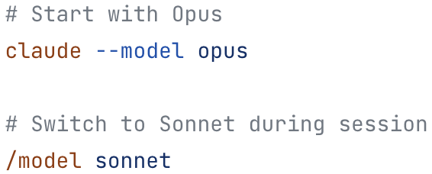

Example settings file:

{

"permissions": {

...

},

"model": "opus"

}

### opusplan model setting

The opusplan model alias provides an automated hybrid approach:

* In plan mode - Uses opus for complex reasoning and architecture decisions
* In execution mode - Automatically switches to sonnet for code generation and implementation

This gives you the best of both worlds: Opus’s superior reasoning for planning, and Sonnet’s efficiency for execution.

<https://code.claude.com/docs/en/common-workflows#how-to-use-plan-mode>

agents

subagents

<https://code.claude.com/docs/en/sub-agents>

Subagents are pre-configured AI personalities that Claude Code can delegate tasks to. Each subagent:

* Has a specific purpose and expertise area
* Uses its own context window separate from the main conversation
* Can be configured with specific tools it’s allowed to use
* Includes a custom system prompt that guides its behavior

When Claude Code encounters a task that matches a subagent’s expertise, it can delegate that task to the specialized subagent, which works independently and returns results.

Suppose you want to use specialized AI subagents to handle specific tasks more effectively.

1. View available subagents

> /agents

This shows all available subagents and lets you create new ones.

2. Use subagents automatically

Claude Code will automatically delegate appropriate tasks to specialized subagents:

> review my recent code changes for security issues

> run all tests and fix any failures

3. Explicitly request specific subagents

> use the code-reviewer subagent to check the auth module

> have the debugger subagent investigate why users can't log in

4. Create custom subagents for your workflow

> /agents

* 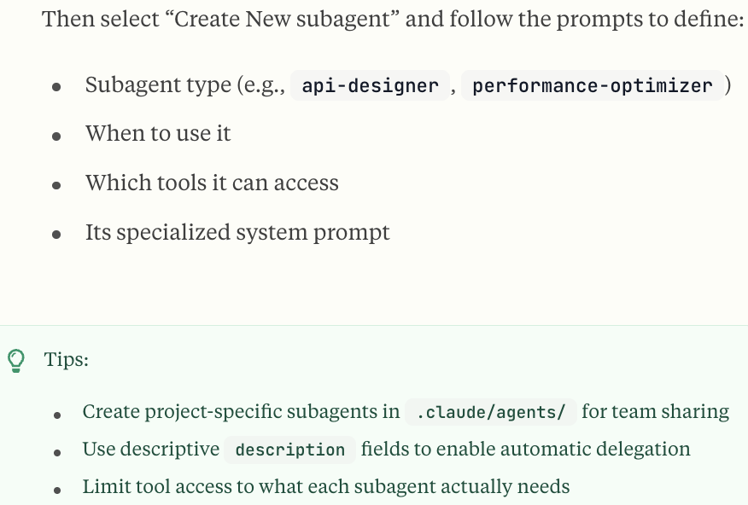

### Key benefits

#### Context preservation

Each subagent operates in its own context, preventing pollution of the main conversation and keeping it focused on high-level objectives.

#### Specialized expertise

Subagents can be fine-tuned with detailed instructions for specific domains, leading to higher success rates on designated tasks.

#### Reusability

Once created, subagents can be used across different projects and shared with your team for consistent workflows.

#### Flexible permissions

Each subagent can have different tool access levels, allowing you to limit powerful tools to specific subagent types.

### Agents flag format

The --agents flag accepts a JSON object that defines one or more custom subagents.

Each subagent requires a unique name (as the key) and a definition object with the following fields:

| **Field** | **Required** | **Description** |
| --- | --- | --- |
| description | Yes | Natural language description of when the subagent should be invoked |
| prompt | Yes | The system prompt that guides the subagent’s behavior |
| tools | No | Array of specific tools the subagent can use (e.g., ["Read", "Edit", "Bash"]). If omitted, inherits all tools |
| model | No | Model alias to use: sonnet, opus, or haiku. If omitted, uses the default subagent model |

claude --agents **'**{

"code-reviewer": {

"description": "Expert code reviewer. Use proactively after code changes.",

"prompt": "You are a senior code reviewer. Focus on code quality, security, and best practices.",

"tools": ["Read", "Grep", "Glob", "Bash"],

"model": "sonnet"

},

"debugger": {

"description": "Debugging specialist for errors and test failures.",

"prompt": "You are an expert debugger. Analyze errors, identify root causes, and provide fixes."

}

}**'**

For more details on creating and using subagents, see the [subagents documentation](https://code.claude.com/docs/en/sub-agents).

hooks

### Extending tools with hooks

You can run custom commands before or after any tool executes using [Claude Code hooks](https://code.claude.com/docs/en/hooks-guide).

For eg, you could automatically run a Python formatter after Claude modifies Python files, or prevent modifications

<https://code.claude.com/docs/en/hooks-guide>

<https://code.claude.com/docs/en/hooks>

MCP

## MCP /slash commands

MCP servers can expose prompts as slash commands that become available in Claude Code. These commands are dynamically discovered from connected MCP servers.

### Command format

MCP commands follow the pattern:

/mcp__<server-name>__<prompt-name> [arguments]

### Features

#### Dynamic discovery

MCP commands are automatically available when:

* An MCP server is connected and active
* The server exposes prompts through the MCP protocol
* The prompts are successfully retrieved during connection

#### Arguments

MCP prompts can accept arguments defined by the server:

# Without arguments

> /mcp__github__list_prs

# With arguments

> /mcp__github__pr_review 456

> /mcp__jira__create_issue "Bug title" high

#### Naming conventions

* Server and prompt names are normalized
* Spaces and special characters become underscores
* Names are lowercased for consistency

### Managing MCP connections

Use the /mcp command to:

* View all configured MCP servers
* Check connection status
* Authenticate with OAuth-enabled servers
* Clear authentication tokens
* View available tools and prompts from each server

### MCP permissions and wildcards

When configuring [permissions for MCP tools](https://code.claude.com/docs/en/iam#tool-specific-permission-rules), note that wildcards are not supported:

* ✅ Correct: mcp__github (approves ALL tools from the github server)
* ✅ Correct: mcp__github__get_issue (approves specific tool)
* ❌ Incorrect: mcp__github__* (wildcards not supported)

To approve all tools from an MCP server, use just the server name: mcp__servername. To approve specific tools only, list each tool individually.

## SlashCommand tool

The SlashCommand tool allows Claude to execute [custom slash commands](https://code.claude.com/docs/en/slash-commands#custom-slash-commands) programmatically during a conversation. This gives Claude the ability to invoke custom commands on your behalf when appropriate.

To encourage Claude to trigger SlashCommand tool, your instructions (prompts, CLAUDE.md, etc.) generally need to reference the command by name with its slash.

Example:

> Run /write-unit-test when you are about to start writing tests.

This tool puts each available custom slash command’s metadata into context up to the character budget limit. You can use /context to monitor token usage and follow the operations below to manage context.

### SlashCommand tool supported commands

SlashCommand tool only supports custom slash commands that:

* Are user-defined. Built-in commands like /compact and /init are *not* supported.
* Have the description frontmatter field populated. We use the description in the context.

For Claude Code versions >= 1.0.124, you can see which custom slash commands SlashCommand tool can invoke by running claude --debug and triggering a query.

### Disable SlashCommand tool

To prevent Claude from executing any slash commands via the tool:

/permissions

# Add to deny rules: SlashCommand

This will also remove SlashCommand tool (and the slash command descriptions) from context.

### Disable specific commands only

To prevent a specific slash command from becoming available, add disable-model-invocation: true to the slash command’s frontmatter.

This will also remove the command’s metadata from context.

### SlashCommand permission rules

The permission rules support:

* Exact match: SlashCommand:/commit (allows only /commit with no arguments)
* Prefix match: SlashCommand:/review-pr:* (allows /review-pr with any arguments)

### Character budget limit

The SlashCommand tool includes a character budget to limit the size of command descriptions shown to Claude. This prevents token overflow when many commands are available.

The budget includes each custom slash command’s name, args, and description.

* Default limit: 15,000 characters
* Custom limit: Set via SLASH_COMMAND_TOOL_CHAR_BUDGET environment variable

When the character budget is exceeded, Claude will see only a subset of the available commands. In /context, a warning will show with “M of N commands”.

settings

* User settings are defined in **~/.claude/settings.json** and apply to all projects.
* Project settings are saved in your project directory:
  + **.claude/settings.json** for settings that are checked into source control and shared with your team
  + **.claude/settings.local.json** for settings that are not checked in, useful for personal preferences and experimentation. Claude Code will configure git to ignore .claude/settings.local.json when it is created.

{

"permissions": {

"allow": [

"Bash(npm run lint)",

"Bash(npm run test:*)",

"Read(~/.zshrc)"

],

"deny": [

"Bash(curl:*)",

"Read(./.env)",

"Read(./.env.*)",

"Read(./secrets/**)"

]

},

"env": {

"CLAUDE_CODE_ENABLE_TELEMETRY": "1",

"OTEL_METRICS_EXPORTER": "otlp"

},

"companyAnnouncements": [

"Welcome to Acme Corp! Review our code guidelines at docs.acme.com",

"Reminder: Code reviews required for all PRs",

"New security policy in effect"

]

}

### Excluding sensitive files

To prevent Claude Code from accessing files containing sensitive information (e.g., API keys, secrets, environment files), use the permissions.deny setting in your .claude/settings.json file:

{

"permissions": {

"deny": [

"Read(./.env)",

"Read(./.env.*)",

"Read(./secrets/**)",

"Read(./config/credentials.json)",

"Read(./build)"

]

}

}

### Subagent configuration

Claude Code supports custom AI subagents that can be configured at both user and project levels. These subagents are stored as Markdown files with YAML frontmatter:

* **User subagents:** ~/.claude/agents/ - Available across all your projects
* **Project subagents:** .claude/agents/ - Specific to your project and can be shared with your team

### Plugin settings

Plugin-related settings in settings.json:

{

"enabledPlugins": {

"formatter@company-tools": true,

"deployer@company-tools": true,

"analyzer@security-plugins": false

},

"extraKnownMarketplaces": {

"company-tools": {

"source": "github",

"repo": "company/claude-plugins"

}

}

}

#### enabledPlugins

Controls which plugins are enabled. Format: "plugin-name@marketplace-name": true/false

Scopes:

* User settings (~/.claude/settings.json): Personal plugin preferences
* Project settings (.claude/settings.json): Project-specific plugins shared with team
* Local settings (.claude/settings.local.json): Per-machine overrides (not committed)

Example:

{

"enabledPlugins": {

"code-formatter@team-tools": true,

"deployment-tools@team-tools": true,

"experimental-features@personal": false

}

}

#### extraKnownMarketplaces

Defines additional marketplaces that should be made available for the repository. Typically used in repository-level settings to ensure team members have access to required plugin sources.

When a repository includes extraKnownMarketplaces:

1. Team members are prompted to install the marketplace when they trust the folder
2. Team members are then prompted to install plugins from that marketplace
3. Users can skip unwanted marketplaces or plugins (stored in user settings)
4. Installation respects trust boundaries and requires explicit consent

## Environment variables

Claude Code supports the following environment variables to control its behavior:

| **Variable** | **Purpose** |
| --- | --- |
| ANTHROPIC_API_KEY | API key sent as X-Api-Key header, typically for the Claude SDK (for interactive usage, run /login) |
| ANTHROPIC_AUTH_TOKEN | Custom value for the Authorization header (the value you set here will be prefixed with Bearer ) |
| ANTHROPIC_CUSTOM_HEADERS | Custom headers you want to add to the request (in Name: Value format) |
| ANTHROPIC_DEFAULT_HAIKU_MODEL | See [Model configuration](https://code.claude.com/docs/en/model-config#environment-variables) |
| ANTHROPIC_DEFAULT_OPUS_MODEL | See [Model configuration](https://code.claude.com/docs/en/model-config#environment-variables) |
| ANTHROPIC_DEFAULT_SONNET_MODEL | See [Model configuration](https://code.claude.com/docs/en/model-config#environment-variables) |
| ANTHROPIC_FOUNDRY_API_KEY | API key for Microsoft Foundry authentication (see [Microsoft Foundry](https://code.claude.com/docs/en/microsoft-foundry)) |
| ANTHROPIC_MODEL | Name of the model setting to use (see [Model Configuration](https://code.claude.com/docs/en/model-config#environment-variables)) |
| ANTHROPIC_SMALL_FAST_MODEL | [DEPRECATED] Name of [Haiku-class model for background tasks](https://code.claude.com/docs/en/costs) |
| ANTHROPIC_SMALL_FAST_MODEL_AWS_REGION | Override AWS region for the Haiku-class model when using Bedrock |
| AWS_BEARER_TOKEN_BEDROCK | Bedrock API key for authentication (see [Bedrock API keys](https://aws.amazon.com/blogs/machine-learning/accelerate-ai-development-with-amazon-bedrock-api-keys/)) |
| BASH_DEFAULT_TIMEOUT_MS | Default timeout for long-running bash commands |
| BASH_MAX_OUTPUT_LENGTH | Maximum number of characters in bash outputs before they are middle-truncated |
| BASH_MAX_TIMEOUT_MS | Maximum timeout the model can set for long-running bash commands |
| CLAUDE_BASH_MAINTAIN_PROJECT_WORKING_DIR | Return to the original working directory after each Bash command |
| CLAUDE_CODE_API_KEY_HELPER_TTL_MS | Interval in milliseconds at which credentials should be refreshed (when using apiKeyHelper) |
| CLAUDE_CODE_CLIENT_CERT | Path to client certificate file for mTLS authentication |
| CLAUDE_CODE_CLIENT_KEY_PASSPHRASE | Passphrase for encrypted CLAUDE_CODE_CLIENT_KEY (optional) |
| CLAUDE_CODE_CLIENT_KEY | Path to client private key file for mTLS authentication |
| CLAUDE_CODE_DISABLE_EXPERIMENTAL_BETAS | Set to 1 to disable Anthropic API-specific anthropic-beta headers. Use this if experiencing issues like “Unexpected value(s) for the anthropic-beta header” when using an LLM gateway with third-party providers |
| CLAUDE_CODE_DISABLE_NONESSENTIAL_TRAFFIC | Equivalent of setting DISABLE_AUTOUPDATER, DISABLE_BUG_COMMAND, DISABLE_ERROR_REPORTING, and DISABLE_TELEMETRY |
| CLAUDE_CODE_DISABLE_TERMINAL_TITLE | Set to 1 to disable automatic terminal title updates based on conversation context |
| CLAUDE_CODE_IDE_SKIP_AUTO_INSTALL | Skip auto-installation of IDE extensions |
| CLAUDE_CODE_MAX_OUTPUT_TOKENS | Set the maximum number of output tokens for most requests |
| CLAUDE_CODE_SKIP_BEDROCK_AUTH | Skip AWS authentication for Bedrock (e.g. when using an LLM gateway) |
| CLAUDE_CODE_SKIP_FOUNDRY_AUTH | Skip Azure authentication for Microsoft Foundry (e.g. when using an LLM gateway) |
| CLAUDE_CODE_SKIP_VERTEX_AUTH | Skip Google authentication for Vertex (e.g. when using an LLM gateway) |
| CLAUDE_CODE_SUBAGENT_MODEL | See [Model configuration](https://code.claude.com/docs/en/model-config) |
| CLAUDE_CODE_USE_BEDROCK | Use [Bedrock](https://code.claude.com/docs/en/amazon-bedrock) |
| CLAUDE_CODE_USE_FOUNDRY | Use [Microsoft Foundry](https://code.claude.com/docs/en/microsoft-foundry) |
| CLAUDE_CODE_USE_VERTEX | Use [Vertex](https://code.claude.com/docs/en/google-vertex-ai) |
| DISABLE_AUTOUPDATER | Set to 1 to disable automatic updates. |
| DISABLE_BUG_COMMAND | Set to 1 to disable the /bug command |
| DISABLE_COST_WARNINGS | Set to 1 to disable cost warning messages |
| DISABLE_ERROR_REPORTING | Set to 1 to opt out of Sentry error reporting |
| DISABLE_NON_ESSENTIAL_MODEL_CALLS | Set to 1 to disable model calls for non-critical paths like flavor text |
| DISABLE_PROMPT_CACHING | Set to 1 to disable prompt caching for all models (takes precedence over per-model settings) |
| DISABLE_PROMPT_CACHING_HAIKU | Set to 1 to disable prompt caching for Haiku models |
| DISABLE_PROMPT_CACHING_OPUS | Set to 1 to disable prompt caching for Opus models |
| DISABLE_PROMPT_CACHING_SONNET | Set to 1 to disable prompt caching for Sonnet models |
| DISABLE_TELEMETRY | Set to 1 to opt out of Statsig telemetry (note that Statsig events do not include user data like code, file paths, or bash commands) |
| HTTP_PROXY | Specify HTTP proxy server for network connections |
| HTTPS_PROXY | Specify HTTPS proxy server for network connections |
| MAX_MCP_OUTPUT_TOKENS | Maximum number of tokens allowed in MCP tool responses. Claude Code displays a warning when output exceeds 10,000 tokens (default: 25000) |
| MAX_THINKING_TOKENS | Enable [extended thinking](https://docs.claude.com/en/docs/build-with-claude/extended-thinking) and set the token budget for the thinking process. Extended thinking improves performance on complex reasoning and coding tasks but impacts [prompt caching efficiency](https://docs.claude.com/en/docs/build-with-claude/prompt-caching#caching-with-thinking-blocks). Disabled by default. |
| MCP_TIMEOUT | Timeout in milliseconds for MCP server startup |
| MCP_TOOL_TIMEOUT | Timeout in milliseconds for MCP tool execution |
| NO_PROXY | List of domains and IPs to which requests will be directly issued, bypassing proxy |
| SLASH_COMMAND_TOOL_CHAR_BUDGET | Maximum number of characters for slash command metadata shown to [SlashCommand tool](https://code.claude.com/docs/en/slash-commands#slashcommand-tool) (default: 15000) |
| USE_BUILTIN_RIPGREP | Set to 0 to use system-installed rg intead of rg included with Claude Code |
| VERTEX_REGION_CLAUDE_3_5_HAIKU | Override region for Claude 3.5 Haiku when using Vertex AI |
| VERTEX_REGION_CLAUDE_3_7_SONNET | Override region for Claude 3.7 Sonnet when using Vertex AI |
| VERTEX_REGION_CLAUDE_4_0_OPUS | Override region for Claude 4.0 Opus when using Vertex AI |
| VERTEX_REGION_CLAUDE_4_0_SONNET | Override region for Claude 4.0 Sonnet when using Vertex AI |
| VERTEX_REGION_CLAUDE_4_1_OPUS | Override region for Claude 4.1 Opus when using Vertex AI |

### Available settings

| **Key** | **Description** | **Example** |
| --- | --- | --- |
| apiKeyHelper | Custom script, to be executed in /bin/sh, to generate an auth value. This value will be sent as X-Api-Key and Authorization: Bearer headers for model requests | /bin/generate_temp_api_key.sh |
| cleanupPeriodDays | How long to locally retain chat transcripts based on last activity date (default: 30 days) | 20 |
| companyAnnouncements | Announcement to display to users at startup. If multiple announcements are provided, they will be cycled through at random. | ["Welcome to Acme Corp! Review our code guidelines at docs.acme.com"] |
| env | Environment variables that will be applied to every session | {"FOO": "bar"} |
| includeCoAuthoredBy | Whether to include the co-authored-by Claude byline in git commits and pull requests (default: true) | false |
| permissions | See table below for structure of permissions. |  |
| hooks | Configure custom commands to run before or after tool executions. See [hooks documentation](https://code.claude.com/docs/en/hooks) | {"PreToolUse": {"Bash": "echo 'Running command...'"}} |
| disableAllHooks | Disable all [hooks](https://code.claude.com/docs/en/hooks) | true |
| model | Override the default model to use for Claude Code | "claude-sonnet-4-5-20250929" |
| statusLine | Configure a custom status line to display context. See [statusLine documentation](https://code.claude.com/docs/en/statusline) | {"type": "command", "command": "~/.claude/statusline.sh"} |
| outputStyle | Configure an output style to adjust the system prompt. See [output styles documentation](https://code.claude.com/docs/en/output-styles) | "Explanatory" |
| forceLoginMethod | Use claudeai to restrict login to Claude.ai accounts, console to restrict login to Claude Console (API usage billing) accounts | claudeai |
| forceLoginOrgUUID | Specify the UUID of an organization to automatically select it during login, bypassing the organization selection step. Requires forceLoginMethod to be set | "xxxxxxxx-xxxx-xxxx-xxxx-xxxxxxxxxxxx" |
| enableAllProjectMcpServers | Automatically approve all MCP servers defined in project .mcp.json files | true |
| enabledMcpjsonServers | List of specific MCP servers from .mcp.json files to approve | ["memory", "github"] |
| disabledMcpjsonServers | List of specific MCP servers from .mcp.json files to reject | ["filesystem"] |
| allowedMcpServers | When set in managed-settings.json, allowlist of MCP servers users can configure. Undefined = no restrictions, empty array = lockdown. Applies to all scopes. Denylist takes precedence. See [Enterprise MCP configuration](https://code.claude.com/docs/en/mcp#enterprise-mcp-configuration) | [{ "serverName": "github" }] |
| deniedMcpServers | When set in managed-settings.json, denylist of MCP servers that are explicitly blocked. Applies to all scopes including enterprise servers. Denylist takes precedence over allowlist. See [Enterprise MCP configuration](https://code.claude.com/docs/en/mcp#enterprise-mcp-configuration) | [{ "serverName": "filesystem" }] |
| awsAuthRefresh | Custom script that modifies the .aws directory (see [advanced credential configuration](https://code.claude.com/docs/en/amazon-bedrock#advanced-credential-configuration)) | aws sso login --profile myprofile |
| awsCredentialExport | Custom script that outputs JSON with AWS credentials (see [advanced credential configuration](https://code.claude.com/docs/en/amazon-bedrock#advanced-credential-configuration)) | /bin/generate_aws_grant.sh |

### Permission settings

| **Keys** | **Description** | **Example** |
| --- | --- | --- |
| allow | Array of [permission rules](https://code.claude.com/docs/en/iam#configuring-permissions) to allow tool use. Note: Bash rules use prefix matching, not regex | [ "Bash(git diff:*)" ] |
| ask | Array of [permission rules](https://code.claude.com/docs/en/iam#configuring-permissions) to ask for confirmation upon tool use. | [ "Bash(git push:*)" ] |
| deny | Array of [permission rules](https://code.claude.com/docs/en/iam#configuring-permissions) to deny tool use. Use this to also exclude sensitive files from Claude Code access. Note: Bash patterns are prefix matches and can be bypassed (see [Bash permission limitations](https://code.claude.com/docs/en/iam#tool-specific-permission-rules)) | [ "WebFetch", "Bash(curl:*)", "Read(./.env)", "Read(./secrets/**)" ] |
| additionalDirectories | Additional [working directories](https://code.claude.com/docs/en/iam#working-directories) that Claude has access to | [ "../docs/" ] |
| defaultMode | Default [permission mode](https://code.claude.com/docs/en/iam#permission-modes) when opening Claude Code | "acceptEdits" |
| disableBypassPermissionsMode | Set to "disable" to prevent bypassPermissions mode from being activated. This disables the --dangerously-skip-permissions command-line flag. See [managed policy settings](https://code.claude.com/docs/en/iam#enterprise-managed-policy-settings) | "disable" |

## Tools available to Claude

Claude Code has access to a set of powerful tools that help it understand and modify your codebase:

| **Tool** | **Description** | **Permission Required** |
| --- | --- | --- |
| AskUserQuestion | Asks the user multiple choice questions to gather information or clarify ambiguity | No |
| Bash | Executes shell commands in your environment | Yes |
| BashOutput | Retrieves output from a background bash shell | No |
| Edit | Makes targeted edits to specific files | Yes |
| ExitPlanMode | Prompts the user to exit plan mode and start coding | Yes |
| Glob | Finds files based on pattern matching | No |
| Grep | Searches for patterns in file contents | No |
| KillShell | Kills a running background bash shell by its ID | No |
| NotebookEdit | Modifies Jupyter notebook cells | Yes |
| Read | Reads the contents of files | No |
| Skill | Executes a skill within the main conversation | Yes |
| SlashCommand | Runs a [custom slash command](https://code.claude.com/docs/en/slash-commands#slashcommand-tool) | Yes |
| Task | Runs a sub-agent to handle complex, multi-step tasks | No |
| TodoWrite | Creates and manages structured task lists | No |
| WebFetch | Fetches content from a specified URL | Yes |
| WebSearch | Performs web searches with domain filtering | Yes |
| Write | Creates or overwrites files | Yes |

Pinecone

DataCamp's Mastering Vector Databases with Pinecone Tutorial

<https://campus.datacamp.com/courses/vector-databases-for-embeddings-with-pinecone/introduction-to-pinecone?ex=1>

#### 

[app.pinecone.io/organizations/-OfCMrMYMrM0u-qcEJao/projects/da77ba12-1345-402c-8a43-c9d18ca68fa3/indexes](https://app.pinecone.io/organizations/-OfCMrMYMrM0u-qcEJao/projects/da77ba12-1345-402c-8a43-c9d18ca68fa3/indexes)

#### Get your API key

curl -o CLAUDE.md <https://docs.pinecone.io/AGENTS-PYTHON.md>

Open Claude Code (claude) and ask Claude to summarize Pinecone best practices:

Confirm you can see the CLAUDE.md file and understand Pinecone best practices.

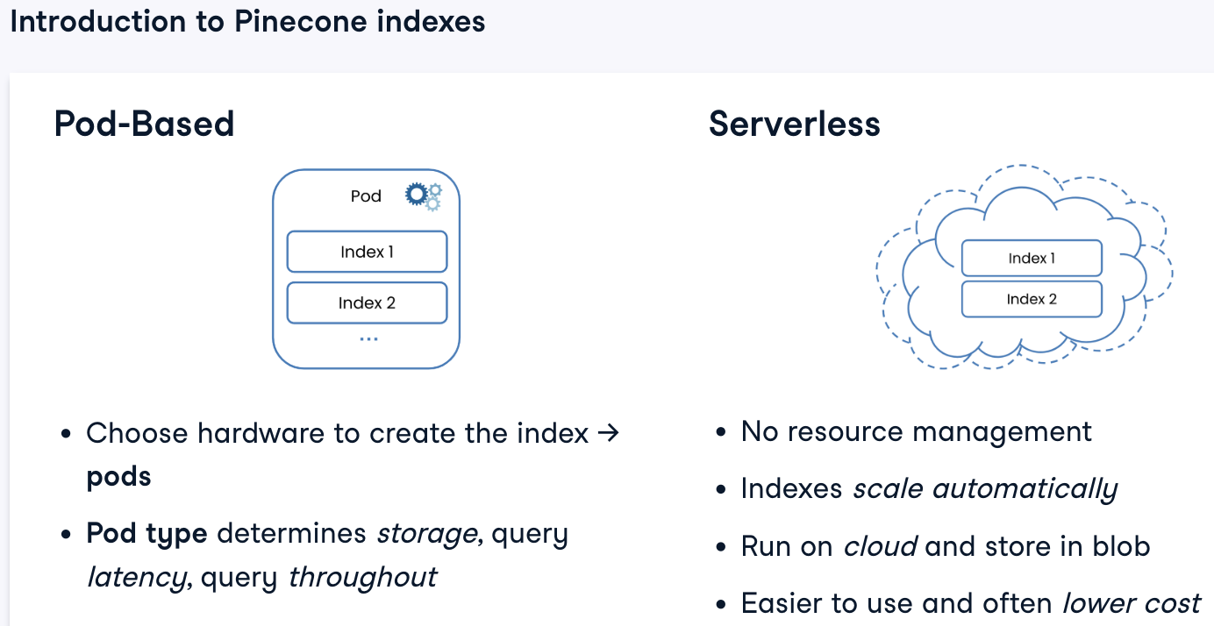

Create account in [Pinecone.io](http://pinecone.io) and get the API Key

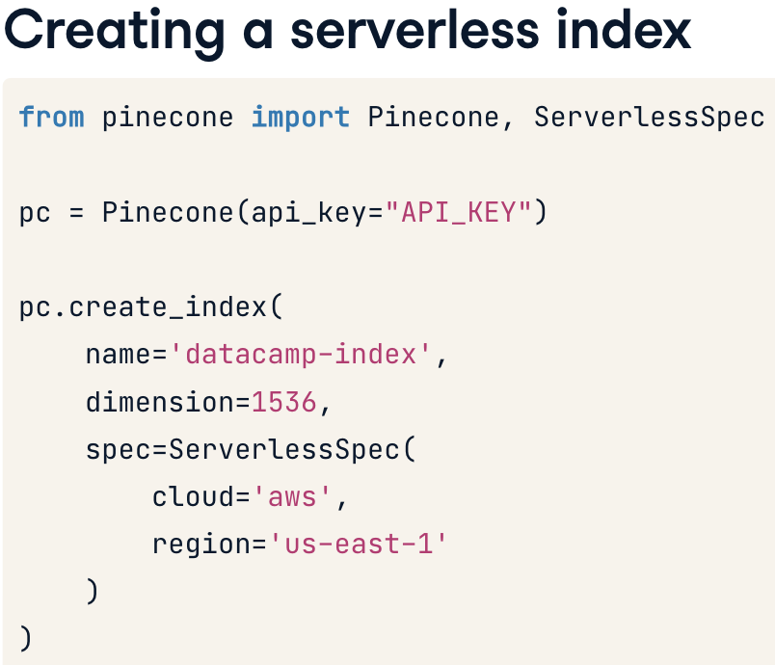

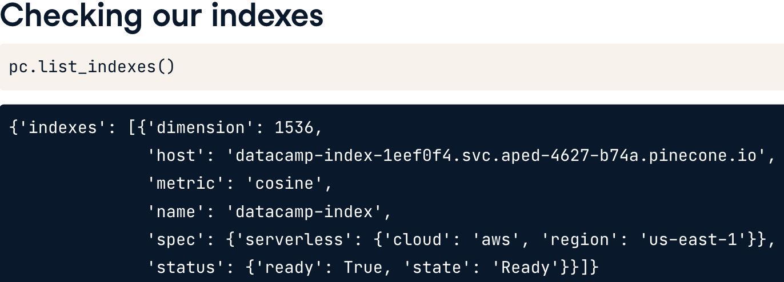



### Index statistics

One of the most common Pinecone index methods is .describe_index_stats(), which returns information about the number of vectors in the index, the proportion of the index that is full - the fullness - and the dimensionality of the index, which should correspond to what was set when the index was created. There's also an empty dictionary to hold namespaces. Let's talk about those.

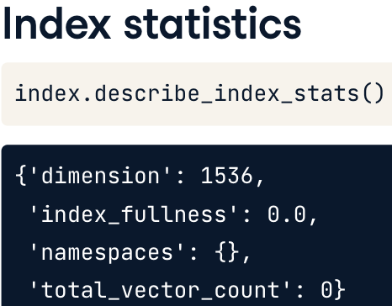

### Namespaces

Namespaces are essentially containers for partitioning indexes into smaller units. This could be to keep distinct datasets or data versions separate, or perhaps to partition group in the parent dataset. Queries and other manipulations are then limited to that namespace. For now, we'll focus on working within a single namespace, but later in the course, we'll discuss distributing vectors and querying across multiple namespaces.

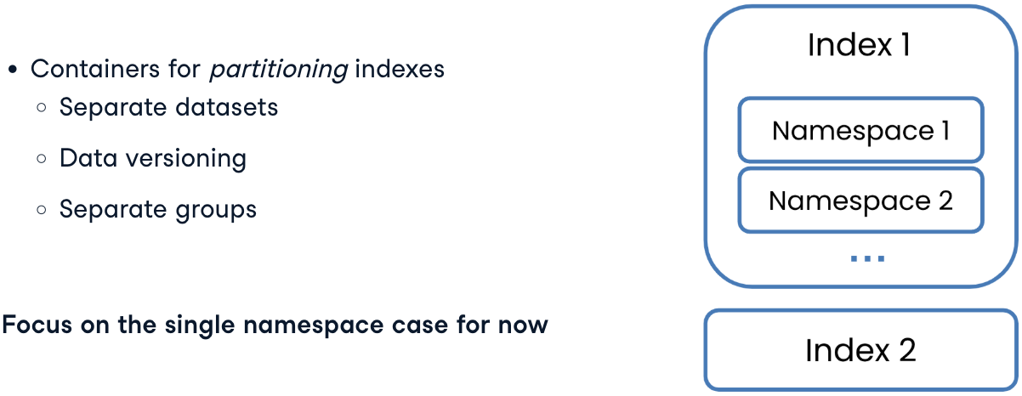

### Organizations

Organizations also play a key role in managing indexes. They provide control over access and billing to different Pinecone projects. Pinecone projects can contain many indexes, so the Pinecone ecosystem consists of a hierarchy of organizations at the top, down to projects, indexes, namespaces, and individual records.

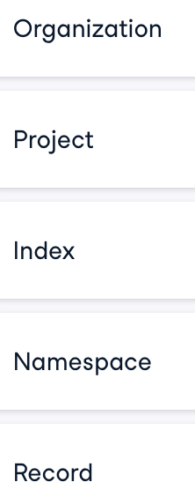 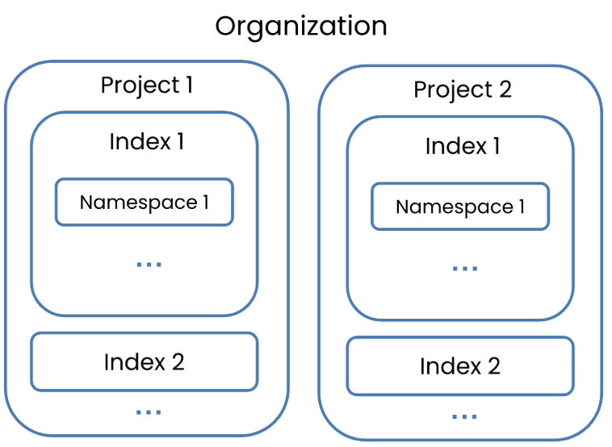

There are two types of organization roles: organization owner and organization user. Organization owners have permissions across the entire organization. This includes managing billing, users, and all projects. Organization users have restricted organization-level permissions. Organization owners invite them to the organization and assign them to specific projects, of which, they become project owners.

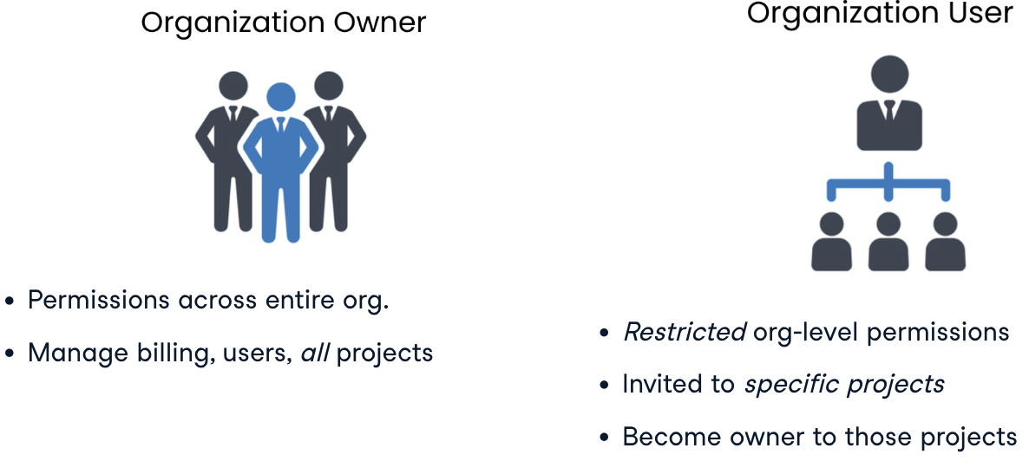

### Deleting indexes

Finally, if our data is no longer of use, or the index no longer suits our use case, we may want to delete it. We can do this with the .delete_index() method. When we do this, we'll see the index disappear in the .list_indexes() output. It's important to note that deleting an index also deletes all of the records it contains, so delete with caution!

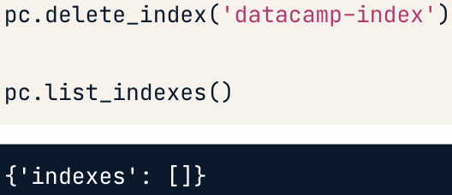

### Ingesting vectors

Here's a series of ten vectors that we'll ingest into our index. It's a list of dictionaries containing unique IDs and vector values. Pinecone requires vectors to be structured in this particular way, so we may need to perform a bit of list and dictionary manipulation to get to this point. Before we start ingesting these vectors, it's also important to check that they have the same dimensionality as the index.

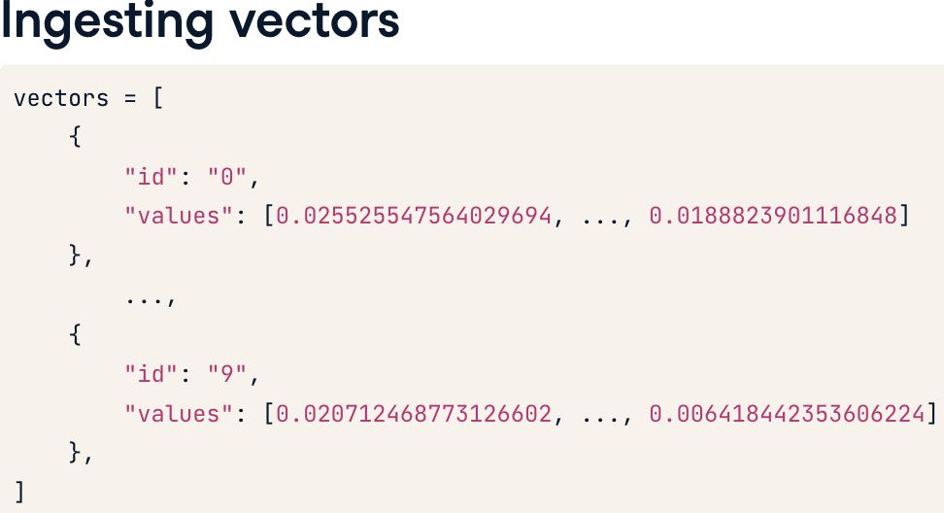

### Checking dimensionality

To do this, we create a list comprehension that checks if the length of the list located under the 'values' key is 1536 for each vector in vectors. To check that this condition is true for every vector, we can call the all() function on the list. Since this is true, we can be sure that these vectors are safe to ingest.

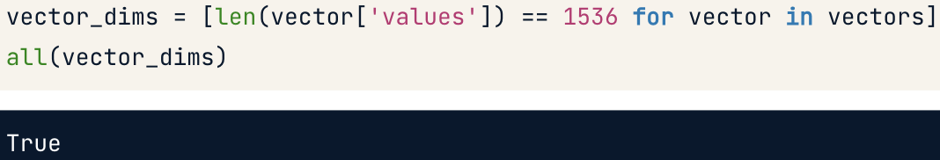

If the dimensionality doesn't match, we'll get an exception message from the API.

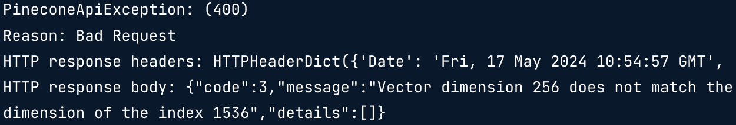

### Upserting vectors

The .upsert() method is commonly used for ingesting vectors. Upsert is a combination of update and insert: if we try to ingest a vector ID that is already present in the index, it will get updated with the new data. If the vector isn't in the index, it will be inserted. We call the .upsert() method on our index, and pass it the vectors. To check that the vectors were successfully upserted, we can call the .describe_index_stats() method. We can see all 10 vectors were inserted. The index_fullness is still zero, as 10 is a tiny fraction of the index's maximum capacity. Note that it can take a few moments for this data to refresh, so .describe_index_stats() may not immediately show the updated statistics.

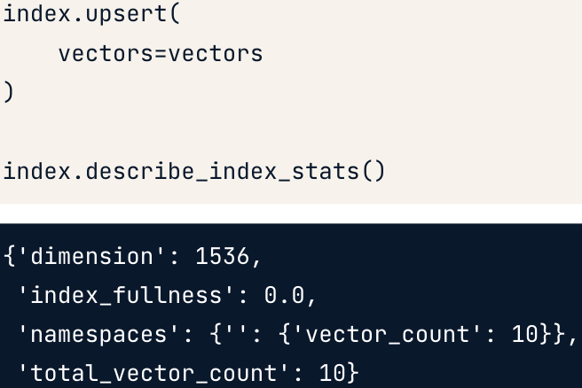

### Ingesting vectors with metadata

Many vectors will have some form of metadata associated with them. Metadata is data about our data, this could be a date or time, a category designation, or user attribution. In our vectors list of dictionaries, it should be stored as a dictionary under the "metadata" key, where metadata labels and values are key:value pairs. Ingesting this data into the database can be very useful. When we come to query the data, rather than having to search through every vector in the index, we can filter by metadata to only search over the most relevant records, which is much faster. We'll cover metadata filtering in the next chapter; for now, we'll ingest it.

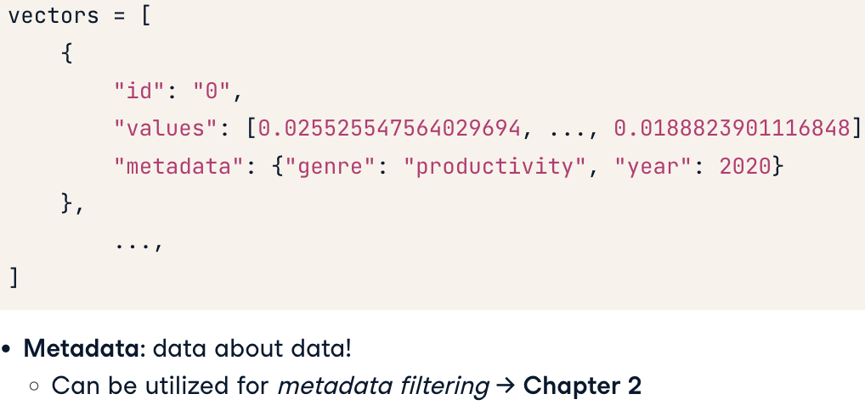

### Upserting vectors with metadata

Fortunately, the syntax is the same as before. Providing that the metadata for structured as a dictionary under a "metadata" key, Pinecone knows exactly what to do!

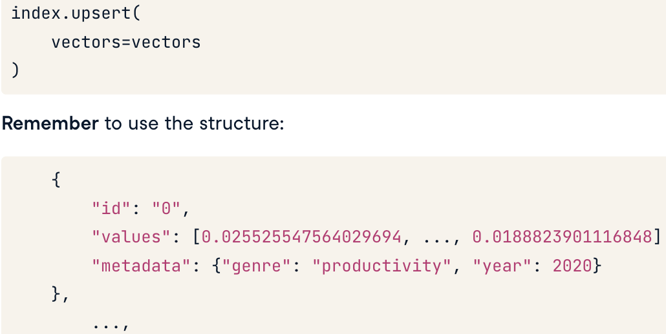

## Pinecone Vector Manipulation in Python

Langchain

Langchain

<https://www.youtube.com/playlist?list=PLZoTAELRMXVOQPRG7VAuHL--y97opD5GQ>

